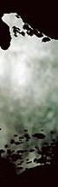


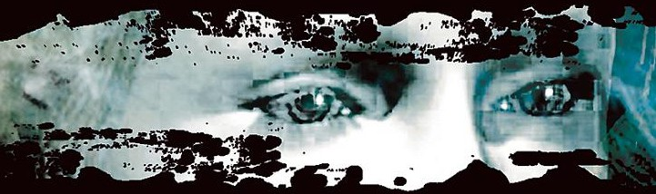
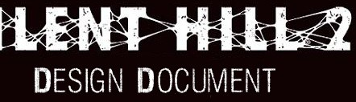


Oliver James Cooke

09000916

Preface
I have always loved the Silent Hill series; it is quite easily one of the main contributors towards my extended admiration for developers. I first played the game when I was fourteen and continuously come back to the franchise year after year. The reason I chose to write about this game is not only because Silent Hill 2 is my favourite game of all time, but an academic reason to invest time in researching the game, far beyond my previous research. A lot of the content of this document is of course prior knowledge of the game, but a good proportion of information has been discovered through this project, allowing me to understand its development with increasing complexity. Two of the main compelling objects of the development I have allowed to bleed into this document, both of which were created before the original design document was realised. The first is the script, which I have thankfully not printed out as it would be far from the direction of the assignment. The second is the main theme for Silent Hill 2, composed again before the original design document was conceived. I have in this case provided that track on a CD; if only to authenticate some part of the original document through this reverse engineering. The original design document has not been published online, and I can only imagine that if it was, I would need a translator to decipher the Japanese text.
I hope you enjoy this document.
Oliver Cooke
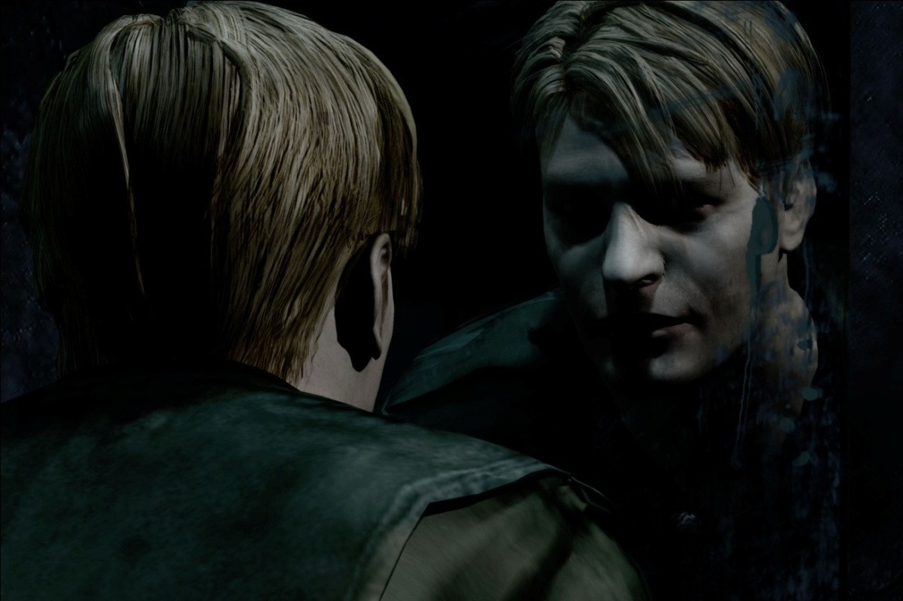

Contents

Game Concept  Introduction Background Description Key Features Genre Platform Concept Art  Game Mechanics  Core Game Play Game Flow Characters Monsters  Game Play Elements Weapon Properties  Game Physics and Statistics Artificial Intelligence Player Controls  Interface  Flowcharts  Functional Requirements Mock Up Screens | P4  P4 P4 P4 P5 P5 P6 P6  P11  P11 P12 P13 P15 P20 P24 P25 P25 P26  P27  P27 P30 P32 | Art and Video  Overall Goals 2D Art  3D Art & Animation Cinematics  Sound and Music  Overall Goals  Sound Effects & Music  Story  Story Overview Multiple Endings  Level Overview  Location Overviews Puzzles  Market Analysis  Target Market Top Performers  Feature Comparison  Bibliography | P33  P33 P34 P34 P34  P35  P35 P35  P36  P36 P40  P42  P42 P52  P58  P58 P58 P59  P60

Game Concept

Introduction

Silent Hill 2 is a 3rd person experience for the Playstation 2 console. The protagonist is James Sunderland who is drawn to Silent Hill after receiving a letter from his dead wife Mary, asking him to meet her there.

Background

Silent Hill 2 will be a continuation of the franchise, a similar feel to the first game, with entirely new technical methods of implementation. Although the game will use a brand new custom engine, many core concepts from the Playstation predecessor will transposed into the new engine code. The reason behind this is the previous success of the Silent Hill engine, which allowed us to create an atmosphere truly unique for the franchise.
Many of the previous team (Team Silent) will be working on this project with the exception of previous director Keiichiro Toyama.

Description

Silent Hill 2 like the first game, places the player at the floor of the town with lots of questions and no answers. It is the players job to unravel the mystery of what happened to attract the protagonist to the town, be that killing lots of monsters, or avoiding as many fights as possible. The few things they cannot avoid are puzzles and the horrifying truth the game has to offer about the circumstances of your avatars arrival.

Key Features

Silent Hill:
Silent Hill 2 will allow players to explore more of the original games location, revealing new and disturbing areas.

Compelling New Story:
Silent Hill 2 will feature a brand new story set in the Silent Hill universe, with brand new characters, puzzles and monsters.

Graphics:
With all new graphics and real to life CG movies, Silent Hill 2 will really immerse players into the game, creating natural characters and breath taking environments. The game will really push for high cinematic quality in both game play and cut scenes.

Dynamic Camera Angles:
Silent Hill 2 will use periodically fixed camera angles to intensify the game play, similar to the first game. This adds to the cinematic approach the game will take.

Sound:
The game will contain a completely new soundtrack composed by Akira Yamaoka
who created the soundtrack for the first game. The game will also use S-Force technology to create a more immersive sound.
Difficulty:
The difficulty for Silent Hill 2 will be set in 2 categories. Riddle level and Enemy level. You can set the level respectively for each individually, using a 3 tier method.

Genre

Silent Hill 2 like its predecessor falls neatly somewhere between survival horror and psychological horror, though unlike the previous game, the psychological horror in Silent Hill 2 will be more apparent. This is due to the story having a more direct approach, and a more explicit subject matter.

Platform
The targeted platform is the Playstation 2 with a sure possibility of an Xbox and PC port depending on the games success. The Playstation 2 will be our primary platform.

Concept Art
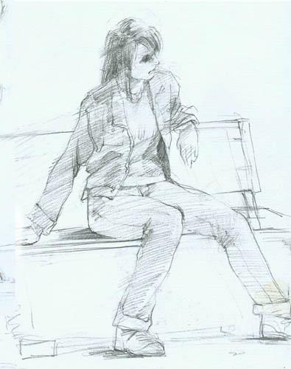
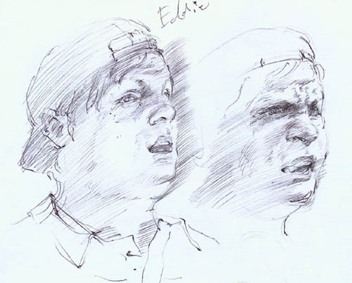
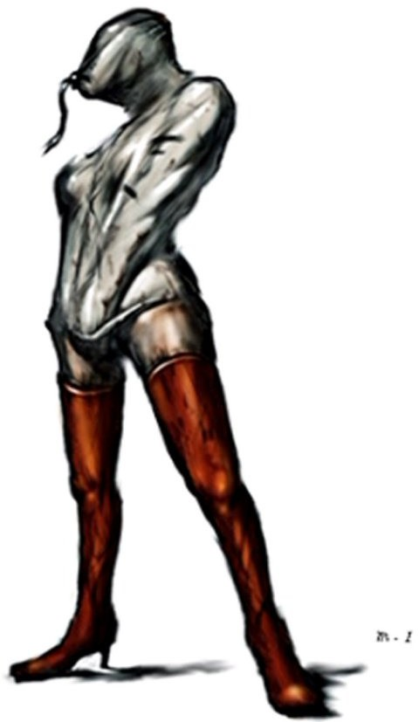
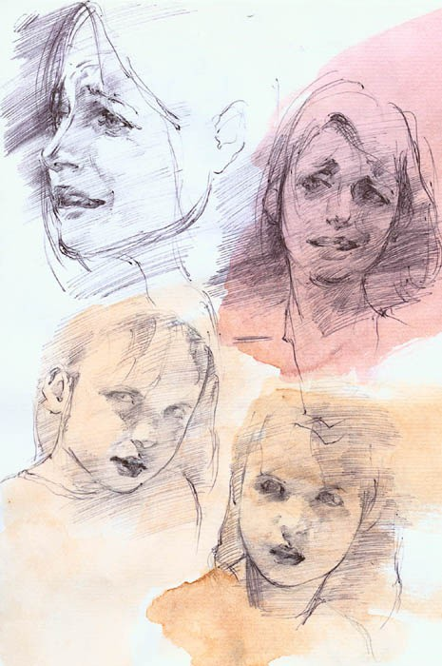

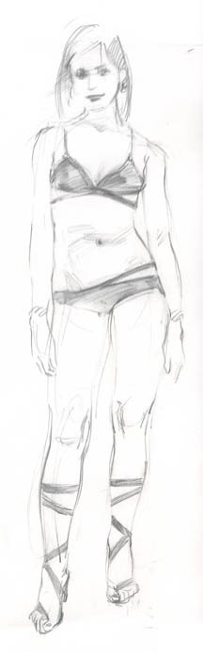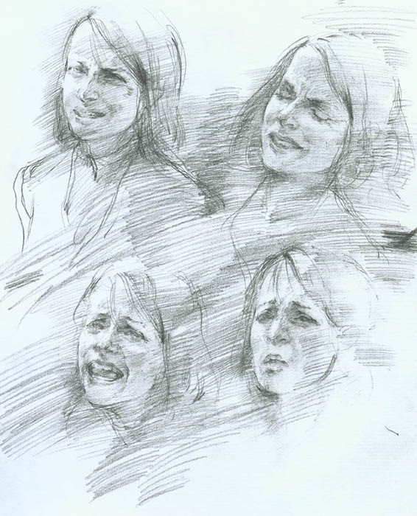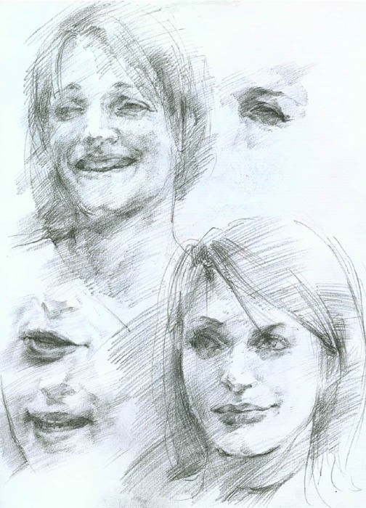

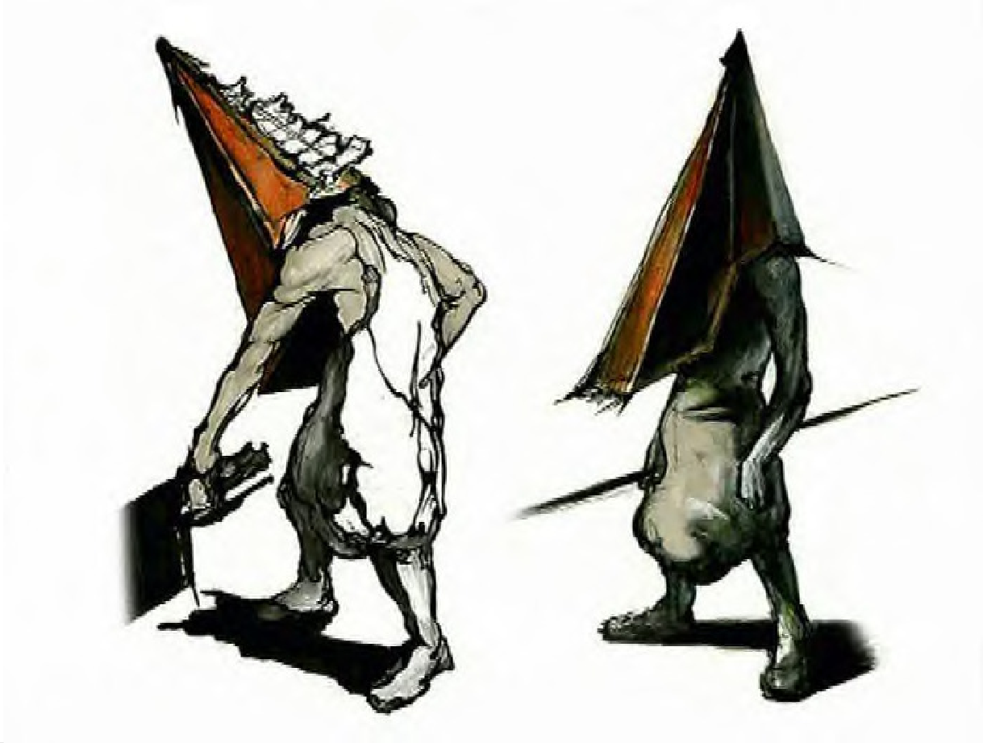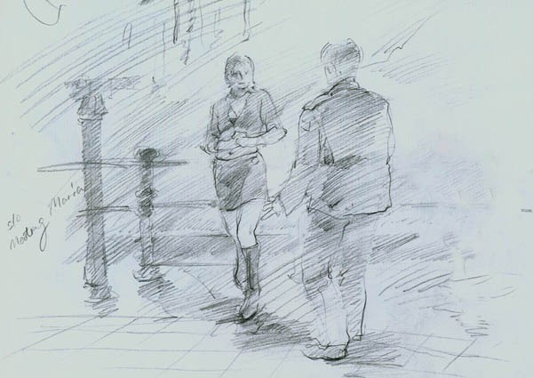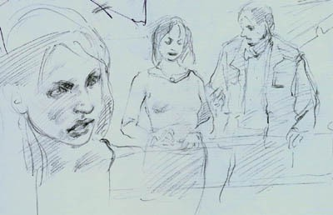

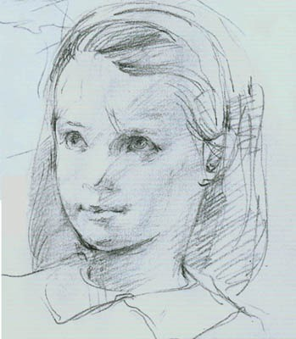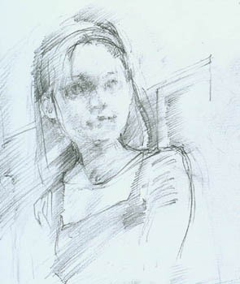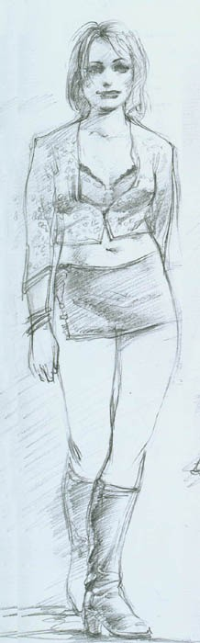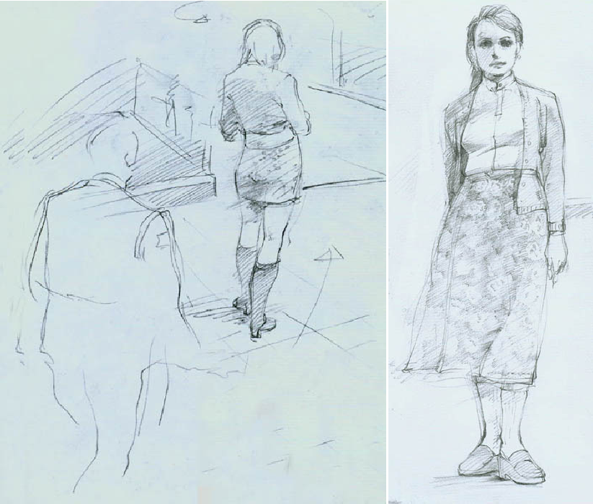

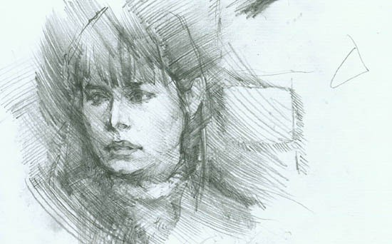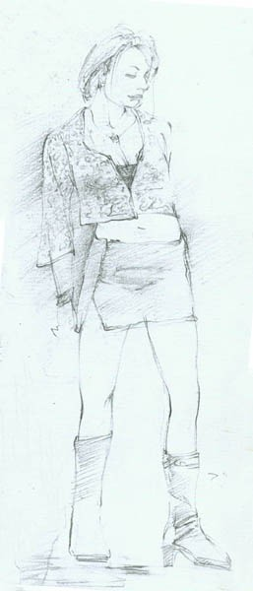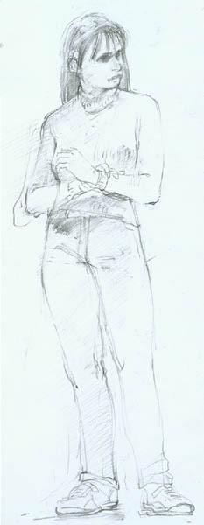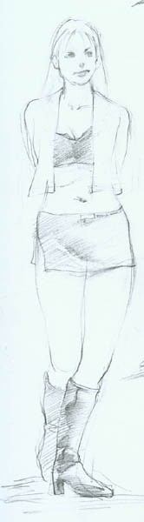

Game Mechanics

Core Game play
The core game play in “Silent Hill 2” will be a mix of both fighting “monsters” and solving puzzles, both of which serve your progress in the game.
Fighting – The fighting in “Silent Hill 2” will be based much around its survival horror counterpart “Resident Evil”. What will set the combat apart from our counterparts is the overall style and pace of the game. Unlike the previous game and much of the “Resident Evil” series, players will be more inclined to avoid battles entirely because of the disturbing nature of their design and sound. A slew of enemies will be roaming the streets, including back alleys and hidden under cars. When it comes to interior exploration, enemies will be dotted around corridors and rooms, but sparsely enough to maintain the feeling of isolation and fear. The game works heavily on the concept that what you don’t see, makes you increasingly scared. An example of this would be to have a long dark corridor with nothing but doors to explore. The player cannot see to the other end of the corridor, creating the fear that something is at the end of the corridor, making the player move apprehensively to the other end. A possible way to describe the combat in “Silent Hill 2” is to compare it to other survival horror games. For example, in survival games such as Resident Evil, you will walk down a corridor with a sick feeling in your stomach, and then all of a sudden a dog will jump out and attack you. You can kill the dog and end the threat until more enemies come along, usually a horde of zombies.
In Silent Hill, you will walk down a corridor with a sick feeling in your stomach, and nothing will happen, the threat doesn’t start and it never ends. Killing one nurse in a somewhat abandoned hospital is not enough to know you’re safe. The fixed camera angles that were a core characteristic of the first game will return, to help intensify this feeling of isolation and apprehension. The two main ways of detecting these monsters will be a flashlight for visual detection, and a radio that emits static when a monster is nearby. Both these methods allow the player to be warned of danger, but the sensory perception of the monsters mean that danger is most certainly on its way. Incidentally, if James leaves his flashlight off in dark areas, the screen will increasingly gain brightness, imitating the effect that his eyes are getting used to the dark.
Puzzles – The Puzzles in “Silent Hill 2” will truly attempt to break usual puzzle solving conventions in the genre. Opposed to the usual puzzle solving which would remove you from

the immersion of the world, the intention here is to incorporate the necessary “pieces of the puzzle” into the narrative. Instead of the cliché “there is a hole here for a crest, go and find it”. The style of the puzzles in “Silent Hill 2” will defiantly reflect the atmosphere and underlying narrative of the game. The audience is promoted to think hard about the solutions, giving the players neither the task of collection, nor the tactic of try every combination. This method was incorporated in the first Silent Hill at heart. The puzzles could be cracked via trial and error, but the iconography surrounding the puzzle made it increasingly disturbing.

Game Flow
Typical game flow in “Silent Hill 2” will be normally quite linear. Players will be given a portion of the narrative, then be given a reason in that narrative to explore a certain section of the town, which will be usually an indoor section (levels). On entering the section, they will encounter 3 things consistently,
- Enemies
- A puzzle or puzzles
- Multiple narrative sections, with one or two intense plot progression scenes
Once the “level” is over, the same basic sequence will happen, filling in a lot of the story and giving the player a reason to continue their progression through the game. Scattered between the usual game flow conventions will be special “set pieces”, which will act as a buffer between two locations in the game, and will mostly house a cut scene, fleshing out characters or plot.
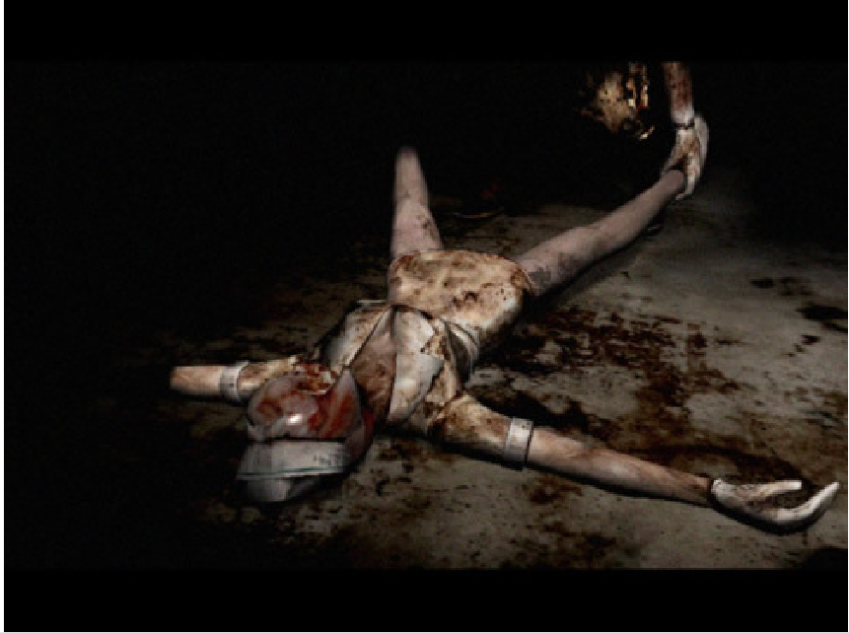

Characters
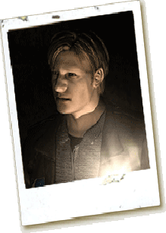
James Sunderland
James is bought to Silent Hill after receiving a letter from his dead wife of 3 years, Mary. James is not the type of person to turn into a mad man, he is calm and rational. Despite this he must go to Silent Hill to understand what is going on. Plagued by his own doubts and a small hope he may be reunited with his wife,
James ventures on into Silent Hill to attempt to uncover the truth as to what is going on. James must now decipher what is real and what is his imagination, in his search for Mary.

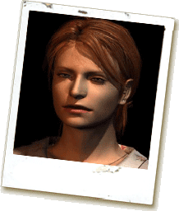
Mary Sunderland
Silent Hill holds many precious memories for Mary and her husband. She enjoyed the visit so much that she made James promise to take her back. Unfortunately that was not a possibility, as 3 years ago she fell victim to a fatal illness. The letter James receives is undoubtedly Marys handwriting, but dead people cant write letters, can they?

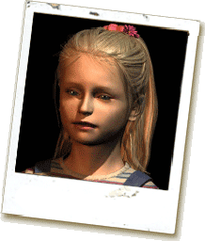
Laura
Laura moves through the streets of Silent
Hill with no fear and fully relaxed. She is stubborn, self willed and appears to be much older mentally than she looks physically. Laura claims to know Mary and is constantly and obstacle in James’ search, in order to further her own.

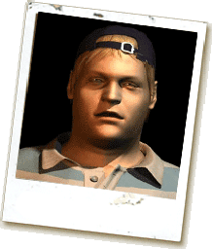
Eddie Dombrowski
Eddie like James is not from Silent Hill and was “summoned” to the town. Eddie appears frightened and helpless to what the town has to offer him. The town offers nothing to Eddie but monsters and ridicule, though something never quite seems right about Eddie, like he’s not all there.

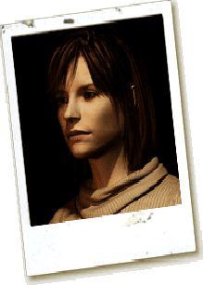
Angela Orosco

Angela comes to Silent Hill to find her family, much like James is. She almost harnesses a split personality, being polite, scared and violent, all in the same discourse. Angela is extremely paranoid and throughout the game she slowly moves into insanity.

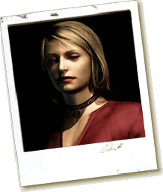
Maria
Maria and Mary practically look identical, all be it a change of hair and clothes. Mary is a mysterious character who never lets on what she really knows. She consistently asks James to save her from the danger that Silent Hill has to offer. Tagging along with James, she spends a lot of time in very precarious
positions.

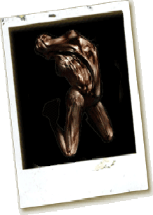
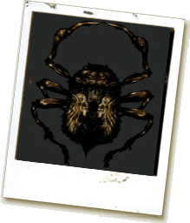

Monsters

The tables below dictate how many hits/shots it takes to vanquish each monster. “X” means no damage can be dealt. “!” means the weapon cannot reach the enemy. “0” means the weapon is introduced later than the monster still remains in the game.

Lying Figure

This monster ears a straight jacket and is extremely quick when it is on the floor, crawling at phenomenal speed. When standing it hobbles towards James, and spews an acid with an amiable range.

Weapon | Beginner | Easy | Normal | Hard
Wooden Plank | 2-8 | 5-11 | 9-15 | 16-24
Steel Pipe | 2-8 | 4-10 | 6-14 | 15-22
Great Knife | 1 | 1 | 1 | 1-3
Handgun | 3-6 | 4-10 | 8-14 | 16-24
Shotgun | 1-2 | 1-3 | 1-4 | 4-7
Hunting Rifle | 2 | 2 | 1-3 | 5-6

Creeper

The creeper is a small insect that normally travel in groups. They will only attack if you block their path. This monster isn’t particularly aggressive, normally biting once or twice before leaving.

Weapon | Beginner | Easy | Normal | Hard
Wooden Plank | 1 | 1-2 | 1-2 | 2-3
Steel Pipe | 1 | 1 | 1 | 1-2
Great Knife | 0 | 0 | 0 | 0
Handgun | 1 | 1-3 | 1-4 | 3-8
Shotgun | 1 | 1-3 | 1-3 | 2-4
Hunting Rifle | 0 | 0 | 0 | 0

Mannequin

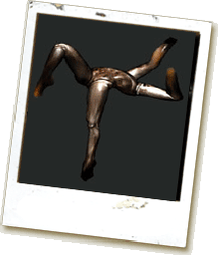
The mannequin is essentially two sets of legs joined together. It has no sensory organs but can still detect light and noise. It attacks with its upper limbs and although limited by range, it can deal a lot of damage.

Weapon | Beginner | Easy | Normal | Hard
Wooden Plank | 2-8 | 5-11 | 8-14 | 16-22
Steel Pipe | 2-8 | 4-10 | 6-13 | 14-20
Great Knife | 1 | 1 | 1 | 2-3
Handgun | 3-6 | 4-9 | 8-12 | 16-22
Shotgun | 1-2 | 1-3 | 1-3 | 2-7
Hunting Rifle | 2 | 2 | 1 | 5-7

Bubble Head Nurse

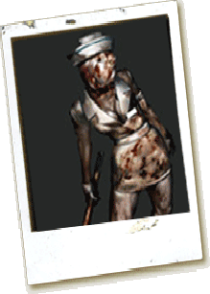
The ascetic characteristics of the nurse are far from its intentions, donning a shirt line that reveals just enough skin and a skirt line to match. The nurse carries a lead pipe around with her to attack James and moves slowly with a limp.

Weapon | Beginner | Easy | Normal | Hard
Wooden Plank | 1-3 | 9-16 | 14-20 | 30-36
Steel Pipe | 1-8 | 5-12 | 8-15 | 18-25
Great Knife | 0 | 0 | 0 | 0
Handgun | 1-10 | 8-10 | 16-24 | 24-38
Shotgun | 1-2 | 1-3 | 1-4 | 3-8
Hunting Rifle | 0 | 0 | 0 | 0

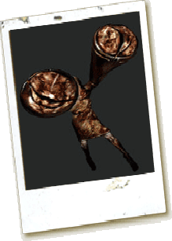
Mandarin

This monster is rare to find. They shimmy along grilles that James walks over, if standing directly above one, a mandarin will attack with a spike.

Weapon | Beginner | Easy | Normal | Hard
Wooden Plank | ! | ! | ! | !
Steel Pipe | ! | ! | ! | !
Great Knife | ! | ! | ! | !
Handgun | 2-3 | 7-8 | 10-12 | 16-20
Shotgun | 1 | 2-3 | 4-5 | 7-8
Hunting Rifle | 1 | 1 | 1-2 | 4-5

Abstract Daddy

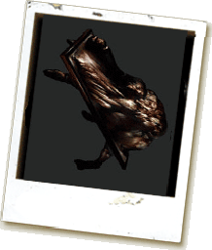
This monster is a manifestation of Angela’s Father, but appears in slightly modified forms around the prison. It resembles a human trapped between a door. It has a deadly jaw which has a tendency to lock onto its victims head.

Weapon | Beginner | Easy | Normal | Hard
Wooden Plank | 2-4 | 8-12 | X | X
Steel Pipe | 2-5 | 7-12 | X | X
Great Knife | 1 | 1 | 1 | 1-2
Handgun | 2-6 | 4-10 | 16-20 | X
Shotgun | 2-3 | 2-3 | 2-5 | 2-7
Hunting Rifle | 2 | 2-3 | 3-5 | 5-7

Flesh Lip

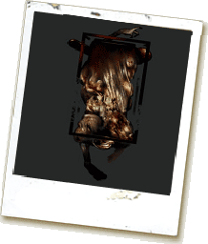
This monster is encountered when Laura locks James in a room looking for Mary’s letter. The flesh lip hangs from the ceiling in a cage much like Maria is killed in at the end of the game. It resembles a body bag with legs extruding out of the bottom, which it uses to strangle its victim.

Weapon | Beginner | Easy | Normal | Hard
Wooden Plank | 6-10 | X | X | X
Steel Pipe | 18-21 | 75-78 | X | X
Great Knife | 0 | 0 | 0 | 0
Handgun | 15 | 54 | 75 | 126
Shotgun | 3-6 | 12-15 | 12-15 | 18-24
Hunting Rifle | 0 | 0 | 0 | 0

Pyramid Headed Monster
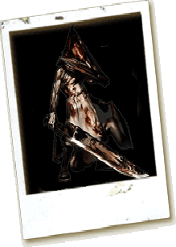
The pyramid headed monster confronts James numerous times throughout the game, like a bad nightmare for James. James cannot defeat this monster, all he can do is escape. It attacks with a great sword or a spear, and when its attacks connect, deals a deadly amount of damage.
This monster holds psychological meaning to James, which the player learns at the end of the game.

Weapon | Beginner | Easy | Normal | Hard
Wooden Plank | Max 18 | X | X | X
Steel Pipe | Max 4 | Max 15 | X | X
Great Knife | Max 3 | Max 5 | Max 13 | Max 36
Handgun | Max 24 | Max 86 | Max 135 | X
Shotgun | Max 9 | Max 26 | Max 50 | X
Hunting Rifle | Max 4 | Max 13 | Max 20 | Max 50

Maria / Mary Demon
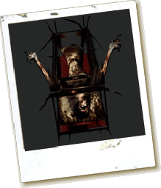
This is the final incarnation of Maria / Mary (depending on which ending you attain). She attacks using tentacles and will do anything she can to kill James, stabbing or strangling him at every opportunity she gets.

Weapon | Beginner | Easy | Normal | Hard
Wooden Plank | 2-3 | 5-7 | 13-15 | X
Steel Pipe | 2 | 5 | 10 | X
Great Knife | 1 | 2 | 3 | 7
Handgun | 10-12 | 36-40 | 50-54 | 176-184
Shotgun | 3-4 | 5-16 | 12-26 | 26-48
Hunting Rifle | 3 | 8 | 16 | 44

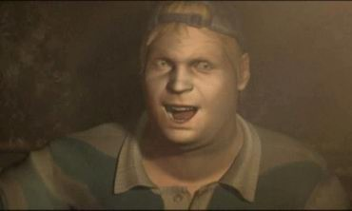
Eddie
Eddie breaks after the pressures of Silent Hill and his own past get to him. Eddie wields a handgun with 6 bullets and has a downtime of 5 seconds when changing ammo. He moves slow and getting to close to him will force him to use his fists.

Weapon | Beginner | Easy | Normal | Hard
Wooden Plank | 1 | 12 | X | X
Steel Pipe | 1 | 6-7 | 8 | 12-14
Great Knife | 1 | 1 | 1 | 2
Handgun | 1 | 15-16 | 32-34 | 42-46
Shotgun | 1 | 3-4 | 4-10 | 7-14
Hunting Rifle | 1 | 4-8 | 7 | 8

Game Play Elements
FlashLight & Radio
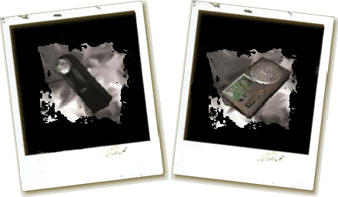
The flashlight helps James see in the dark, helping him to see important items and monsters. Equally having the flashlight on makes James easier to be spotted by danger. The radio helps James detect nearby enemies, emitting a loud static when danger is nearby. Like the flashlight, the radio can also draw attention to James. The radio does not work for normal transmissions.

James’ Personal Items
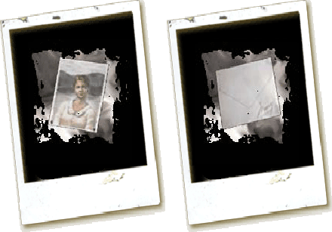
James’ personal items consist of a photo of Mary and a letter from Mary.

Health Items
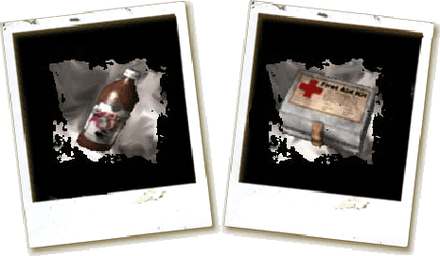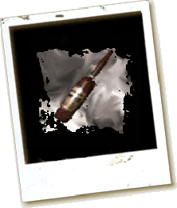
When used, the health drink restores 25% health. This item is fairly common. The first aid kit can restore 50% of health. This item is considerably rare. The Ampoule has the ability to restore 100% of health. This item is extremely rare and wont present itself easily.

Blunt Weapons
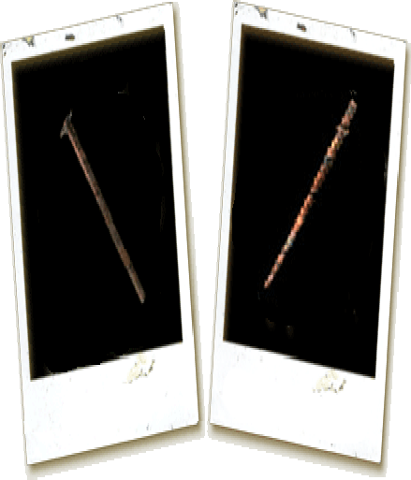
The plank is the first weapon in the game. It delivers limited damage and has a limited range. The Steel pipe swings faster, does medium damage and has a medium range. Both can deliver light and heavy attacks.

Firearms
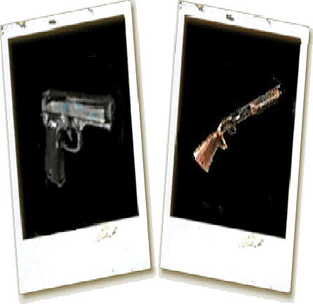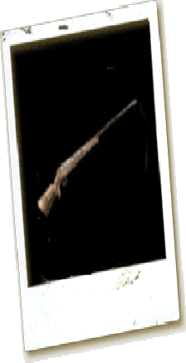
The three firearms in the game are the pistol, shotgun and hunting rifle. The pistol has a high rate of fire, holds 10 bullets and does a limited amount of damage. The Shotgun has a slower rate of fire, holds 6 bullets and is extremely effective in close range combat. The hunting rife has an extremely low rate of fire, holds 4 bullets and does and extreme amount of damage from close or far away. All three require ammo, which is placed around the game.

Other Weapons
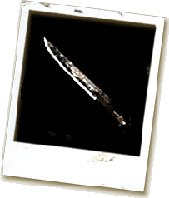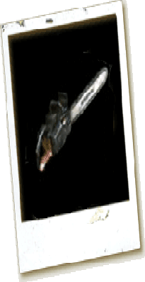
The great knife is the same weapon used by the pyramid headed monster. It is the slowest weapon in the game, but can normally kill anything with one swing. The chainsaw is extremely effective in close range combat, but can only be used after a brief waiting period to start the chainsaw up.

Keys
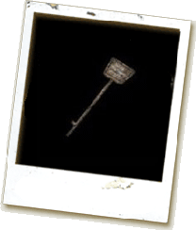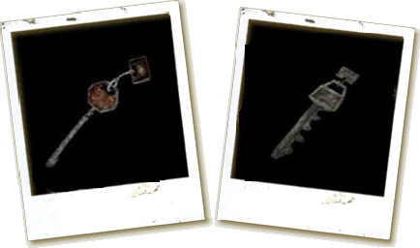
There are a selection of keys throughout the game that open a variety of things like doors or chests.

Various Puzzle Items
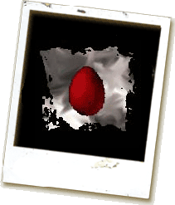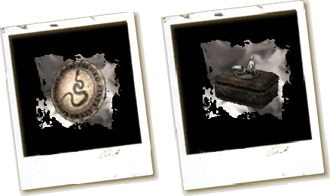
These puzzle items will be used in order to unlock new items needed to progress the story. Some can be manipulated and others are just required to be used correctly.
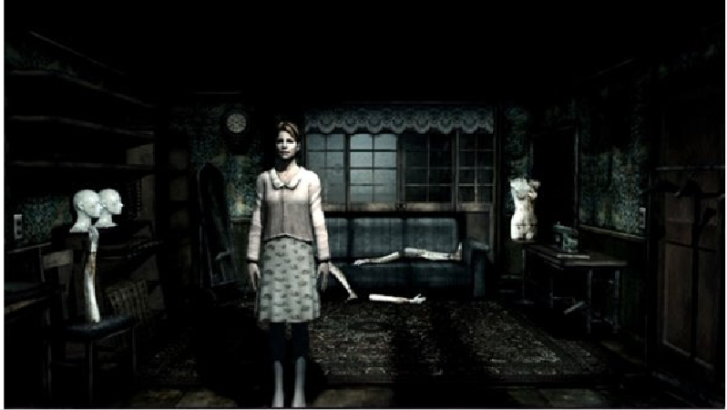

Weapon Properties
Blunt and Special Weapons

Weapon | Wooden Plank | Steel Pipe | Great Knife | Chainsaw
Possible to move whilst holding  weapon | Yes | Yes | No | Yes
Light attack | Side swipe with limited radius | Blow | Side swipe with large radius | Side swipe with medium radius
Range | Slight | Large | Large | Medium
Sequence of Blows | Rapid | Rapid | Very slow | Rapid
Special Feature | Two hits in quick succession are possible | James takes a small step forward at each blow | Even when your weapon is lowered, only very slow movements are possible | Motor needs to be started before use
Heavy Attack | Overhead blow | Overhead blow | Overhead blow | Stab
Range | Medium | Medium | Medium | Medium
Sequence of Blows | Rapid/medium | Rapid | Very slow | Rapid

Firearms

Weapon | Handgun | Shotgun | Hunting Rifle
Possible to move while holding the  weapon at ready | Yes | Yes | No
Possible to move while shooting | Yes | No | No
Bullets or shells per  magazine | 10 | 6 | 4
1 shot every ...  seconds | 0.5 | 2 | 1.5
Total quantity of ammo | High | Medium | Low

Game Physics and Statistics

Movement – James has 3 primary speeds, walk, jog and run. The player can primarily walk anywhere at a set pace, the act of walking long distances will not take an effect on the avatar. The next two speeds jog and run, are determined by how “tired” James is, this will usually be calculated by how long James has been running consistently. If James runs for a long distance it will eventually slow into a jog, after a period of jogging James will then burst into running until “tired” again. This cool down time can be reduced by walking as opposed to jogging. The tactic of running then stopping just before James gets tired, then bursting into another lengthy run, will be abolished and will be calculated on how much running James has done on average. These 3 speeds can be further altered by being injured. Having James’ health drop below a certain threshold will reduce the speed of usual movement. James is also able to sidestep to the left and right, as well as perform a 180 degree turn.

Combat – The rate of combat depends on which weapon the player decided to arm James with some close combat weapons will take longer to strike, but will inherently deal more damage. This idea can be easily transposed to firearms by allowing the better weapons to deal more damage, but taking longer to reload, leaving the avatar prone to attacks. When enemies get attacked, they react to the damage depending on their current health. This can mean they will either be stopped from moving, get pushed back or fall to the floor. When James gets hit, there is a brief moment after that the player becomes prone to extra attacks and cannot defend, just as if someone was pushed over in real life. James also has the ability to coup de grace enemies that are in a prone position; he accomplishes this by stamping on them.

Artificial Intelligence

The enemies in the game will react with two basic senses, sight and sound. These two senses will give the AI an impression of carnal attacks. Unlike the “Resident Evil” series in which the zombies attack with a need to feed, the monsters in “Silent Hill 2” attack with nothing more than basic instinct.
Sight – Enemies work on a radial system primarily. The basic theory is, if James gets too close to the enemy, the enemy will advance with intent to harm. Some enemies when hit to the floor, will have the ability to crawl away from James at a fast pace, exiting the players sight from the screen. This is used as a general regrouping mechanism for the enemies, in which they then have time to stand up and perform better attacks, as opposed to attacking from the floor. In places of darkness, the radial system is dependent on the flashlight James carries. If the

flashlight is turned off then the enemy radius is dramatically reduced and will only attack if the player near enough bumps into the enemy.
Sound – Enemies can also base attacks from the sounds they hear. The sound of footsteps and the radio which James carries, act as a beacon for enemies. In turn the enemies will advance to the source of the noise and attack James. Enemies will not hear the footsteps of James while walking.
The only time these two rules do not apply to the enemies AI is if there is a specific “set piece”, in which the enemy is scripted to act in a certain way.

Player Controls


Analogue stick = Move Triangle = Call map / Hide Map / Hide inventory Analogue stick + Square = Run Square = Run / Hide Map / Hide inventory
L1/R1 = Side Step Circle = Flashlight on/off / Hide Map/ Hide inventory L1+R1 = Turn 180 degrees Cross = Confirm action / Examine / Take or use
L2 = Centre camera items/ Hold R2 simultaneously to perform
R2 = Ready attack an attack. (Press Cross = Light attack,
R3 = Fully restore health Hold Cross = Heavy attack) Select = Pause L1+R1+Start+Select = Soft Reset Start = Open inventory

Interface

Flowcharts
The following are flow charts for the different screens and their individual data flow. The save screen and load screen are shared so it is only included once in the start screen flow chart.
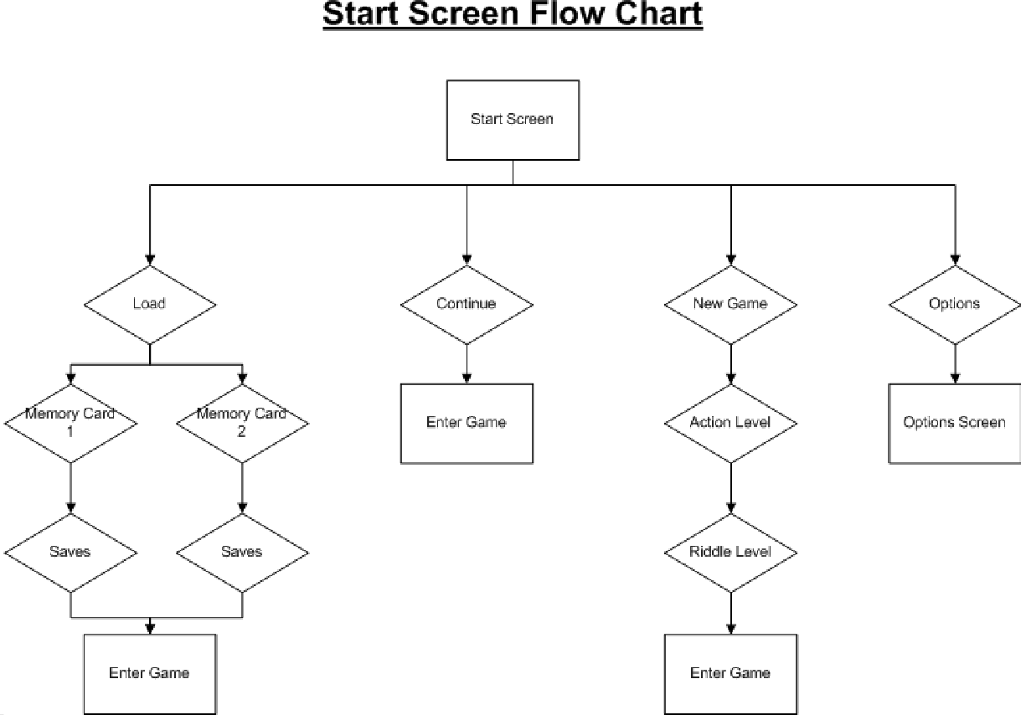

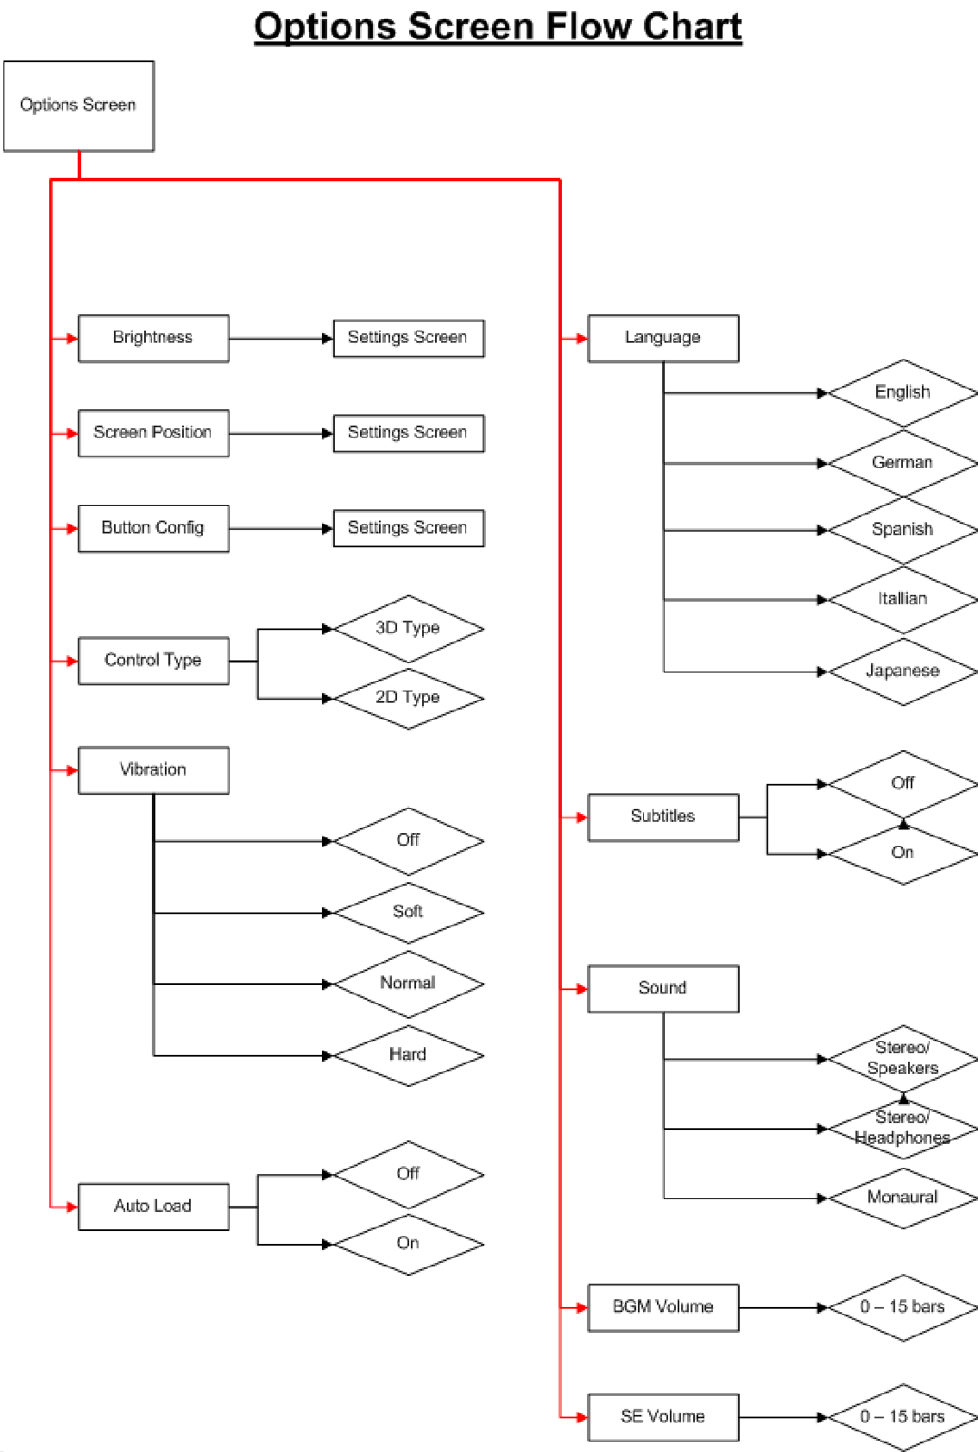

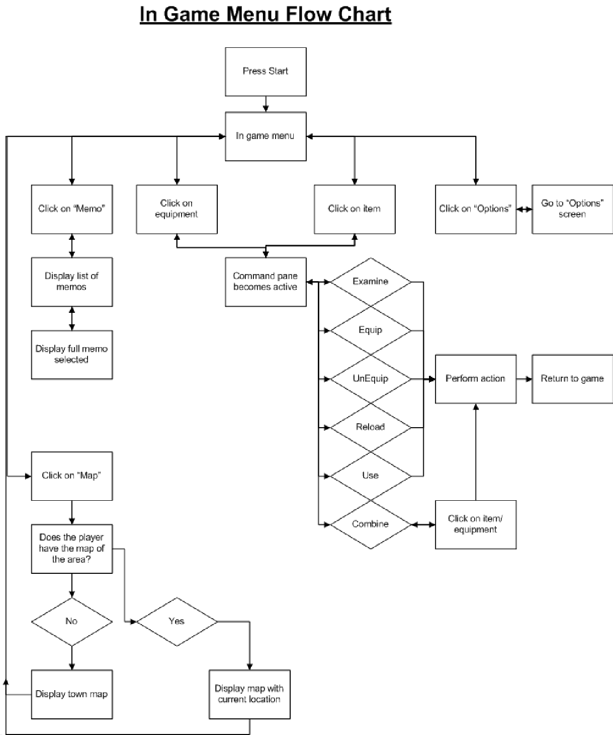

Functional Requirements
- - Start Screen
The selection on the start screen uses a simple highlighted selection.

1:1 - Load
The load screen is able to move across both memory card slots and be able to pick from multiple saves.
1:2 – Continue
Clicking on continue will immediately take you into your last game save by
date/time.
1:3 – New Game
The new game screen has both the settings for action level and riddle level. Once the riddle level has been set, the game automatically starts up.
1:4 – Options
The options screen includes, Brightness
Screen Position Button Config Control Type Vibration
Auto Load Language Subtitles Sound
BGM Volume SE Volume

- - In Game
Pressing start will bring up the in game menu.

2:1 – Status
The status section is not interactive and shows up the avatars health.
2:2 – Equipment
The equipment shows what you currently have equipped. This is interactive and clicking on the piece of equipment activates the command section.

2:3 – Command
The command section is where you can decide what to do with the selected item or equipment. These functions are,
Examine Equip Unequip Reload Use Combine
2:4 – Options
These options are the same at the start screen, and use the same menu layout.
2:5 – Memo
Clicking this opens up another window containing the “header” of each memo you have collected. You are highlighted over the last one you obtained, you can move up and down a list and click on one to read it.
2:6 – Map
Clicking on the map text opens up the current map of the building, provided that it has been acquired. If not, a simple message states you don’t have a map of this area, and it opens up the main map of “Silent Hill” by default.
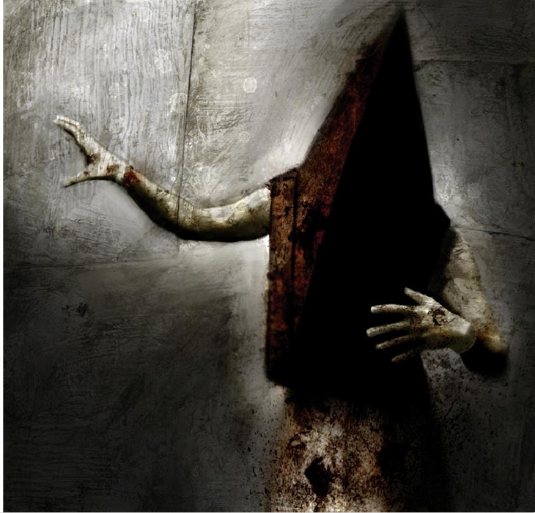

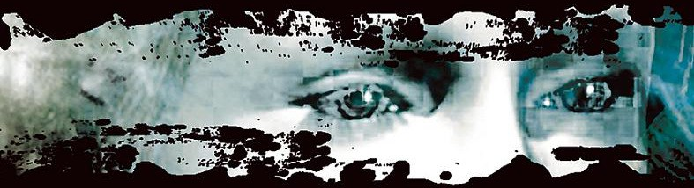
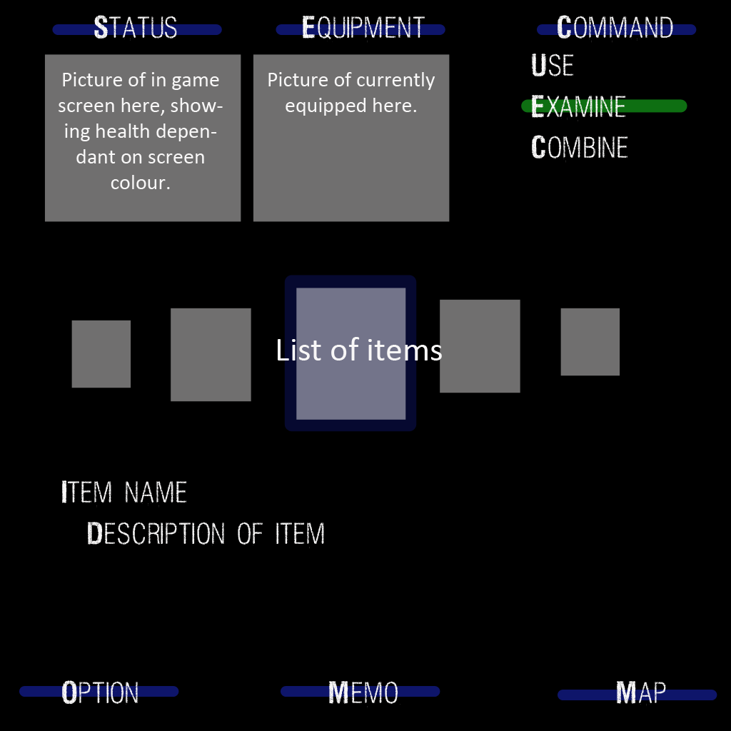
Mock Up Screens
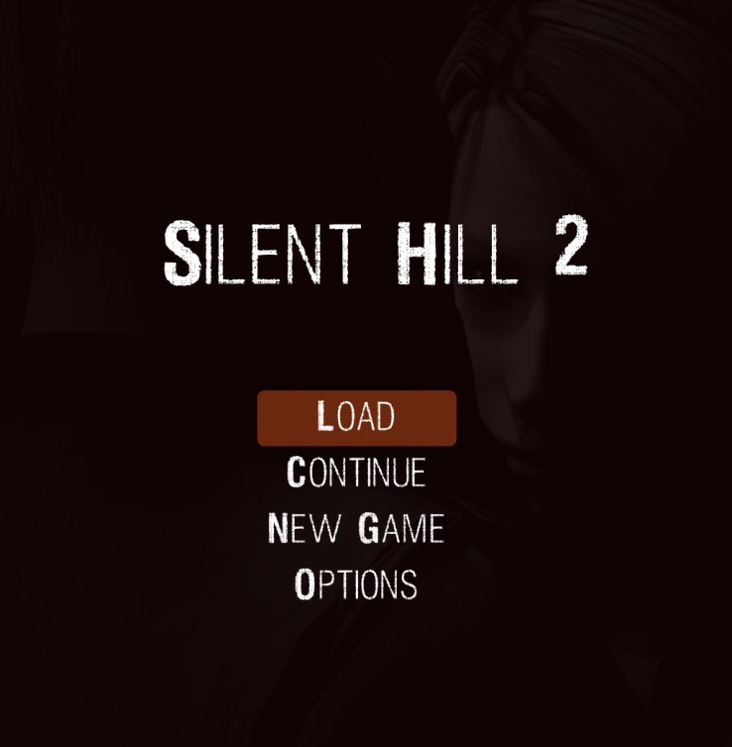
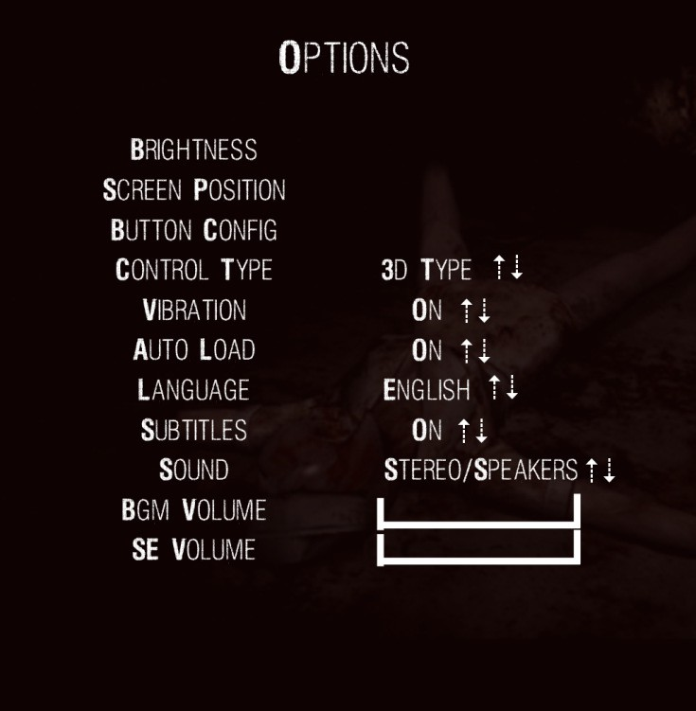

Art and Video

Overall Goals

Artistic style was a true staple for the previous game, Silent Hill 2 will intend to bring the same motifs of the first game with unbelievable vibrancy and character, into this generation of consoles. The true artistic goal of this project is based on a concept of simultaneous repulsion and attraction, to define their impact to the player. Interior environments will look abandoned and disgusting, but at the same time will have a distinct charm. Almost like grim visual backgrounds and set pieces will have an aura of mystery about them. The exterior environments will be treated differently. The town will be given a true sense of isolation by lack of interactivity, making the town seem bigger that it really is. One key sequence intended for implementation is the extended walk to the town of Silent Hill. We intentionally want this sequence to be long, as to give the player a true feeling that the town is isolated and soon you will be. Additionally the game will have a grainy filter for the entirety of the game, to dirty the images and give them character. In addition, various artistic decisions placed around the game will give the player subliminal help with understanding the story. One idea of which is finding a person dead slumped in a chair, the exact character model will be of the main character James, but the art direction of the body will make it only slightly distinguishable as your character. All of these visual elements will aid each other to convey a mysterious feeling of solitude and isolation, which is the true nature of the game.
The monsters in the game will also adopt this method of simultaneous repulsion and attraction. The monsters are not extremely abstract from human anatomy, giving the player a fear of relation to the very things they are scared of or even kill. Hits of sexuality will be intentionally placed in the art direction, making the nurse’s clothes rather short, and the mannequins legs silky smooth. These intentional decisions are implemented to heighten the male insinuation of the pyramid head monster, a male slaughtering and suggestively sodomizing the female related monsters.
The human characters will take on a mundane approach on purpose. None of them are meant to be super heroes and imperfections are needed to appreciate the fragility of the lives at stake. All of the characters except Laura have skin imperfections and extremely normal clothes. Incidentally the same face is used for both Mary and Maria, further strengthening their roles in the story.

2D Art

- All menu objects (weapons, items etc)
- All menu backgrounds
- Ending credits backgrounds
- All textures for environments
- Box art / Manual art
- Advertisement art (mostly comprising of character renders with alterations)
- Web page art
- Town maps
- All individual pieces of art in game (paintings)
- Ending Credits

3D Art & Animation

- All aspects of character animation
- All modelled assets (town, buildings, items)
- All Character & monster models

Cinematics

- All in engine cut scenes
- All pre rendered FMV cut scenes
- Promotional video for internet spots

Sound and Music

Overall goals

The overall goal of the effects direction is to remove itself from the formality of other such survival horror games, such as the “Resident Evil” series. The intentions are to make sounds that have a physical reaction with the player, almost like there is something crawling underneath your skin. As opposed to the usual sounds you would hear every day being used in a different context.
The musical composition and sound effects in the game will be entirely handled by Akira Yamaoka. The main theme for the game was composed before this document was made, based entirely off the script. The rest of the musical composition will convey the true melancholy of the script, which like the game, will use unlikely combinations to portray a distinct feeling to the player.

Sound Effects & Music

To prevent repetition many of the “mundane” sounds being used will be sampled multiple times. For example opening a door will not always have the same opening sound, and footsteps will be different every pace. The more unusual effects will be comprised from numerous different sources, from synthesized sounds, to multiple overlays of samples from animals.
The music throughout the game will have a constant motif of melancholy. There will obviously be no upbeat, major key jingles for completing milestones in game. Even upon picking up crucial items to progress the story, the jingle will be small and minor key. A lot of the music could be reused during similar sequences, but also, silence will be a key contributing factor, setting suspense and mood for the player.
Combinations of sad melodies with strong beats, abstract synthesized composition and elegant piano pieces, will really set the tone for the game and bring out the games fragile story. A contrast of the ugly and the beautiful, or as stated before, repulsion and attraction.

Story
The beginning of the game introduces James Sunderland, the main character and avatar of the player. The game starts with James on the cusp of Silent Hill, standing on the observation deck overlooking Toluca Lake. James has travelled to Silent Hill after receiving a letter from his wife Mary, who had apparently died from an illness 3 years prior to James’ return to the town. The letter James possesses states that Mary is waiting for him in their “special place”. This somewhat confuses James, as the whole town itself could be seen as their “special place”. James considers that the park by the lake could be the location the letter mentions, and decides to leave the observation deck and head to town.
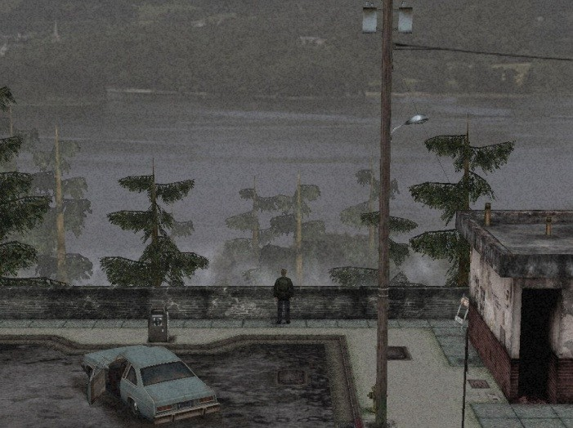
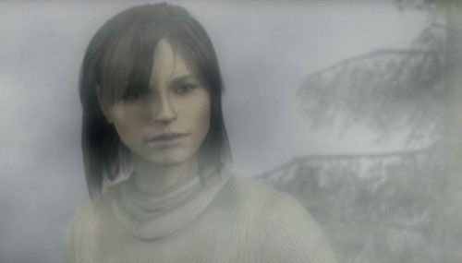
After a small amount of travel, James runs into a teenage girl by the name of Angela, in a graveyard. Angela is startled by James, showing a sheer disbelief when James mentions that he is lost. Angela states she is looking for her family in Silent Hill and points James in the right direction. James eventually reaches the town to realise to once beautiful town he and Mary once loved, is now no more. A fog shrouds the entirety of the towns rotting abandonment, as well as the humanoid monsters roaming the streets, waiting to attack James. With the initial route to Rosewater Park blocked, James is forced to find another route, so he decides to try another route, through Woodside Apartments.

Inside the apartments, James meets up with Eddie, who is vomiting in a toilet. Eddie defensively denies his involvement with a dead body laying only a few feet away from him.
Eddie like James claims to have been summoned to the town, and can not quite understand their own rational for being there. It is here that James also runs into a little girl called Laura. Laura appears to be immune to the effects the town appears to be having on James. She also has an unexplained loathing for James, as well as knowing the identity of Mary.
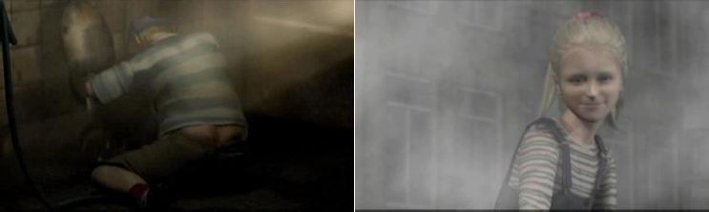
After taking a small leap into the parallel Blue Creek Apartments, James runs into Angela again, but this time lying on the floor in one of the rooms wielding a knife. Angela portrays a more sporadic mood of fear, aggression and politeness, all in the same discourse with James. Fearing she may be suicidal, James acquires the knife from Angela and she leaves in a flurry of emotions. During this time James encounters the Pyramid headed monster for the first time, sodomizing and killing other monsters in various locations around the apartments.
Nothing in James arsenal will kill the monster, and James decides to flee.
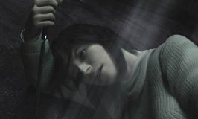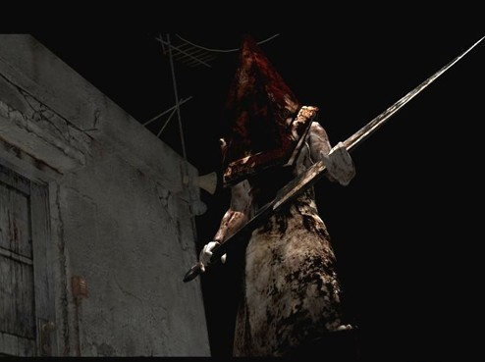
When James finally reaches his destination, he is met by Maria, who is near enough identical to Mary, with the exception of more provocative clothes and an attitude to match. Maria appears to have insight into situations that only James or Mary would have, talking intelligently about Mary’s death and other “special places”. James denominates that The Lakeview Hotel could be the “special place” Mary talks about, thus that will be his next destination. There are no boats at the dock to cross Toluca Lake to reach the hotel, so naturally, James must find another way. Though not alone, as Maria guilt trips James into letting her accompany him. James detours through the bowling alley meeting back up with Eddie and a quick exiting Laura. Eddie refuses to chase after Laura and opts to stay and eat pizza. On James’ exit from the bowling alley, Maria claims to have chased the little girl and convinces James they need to find her out of concern.

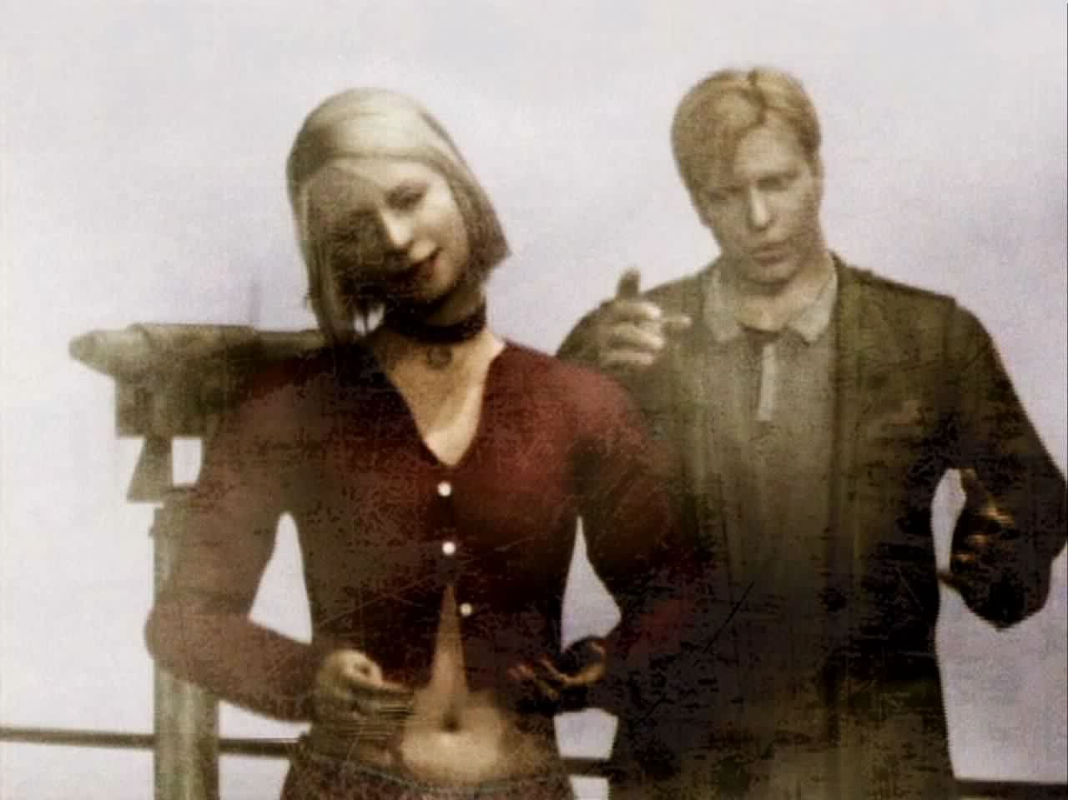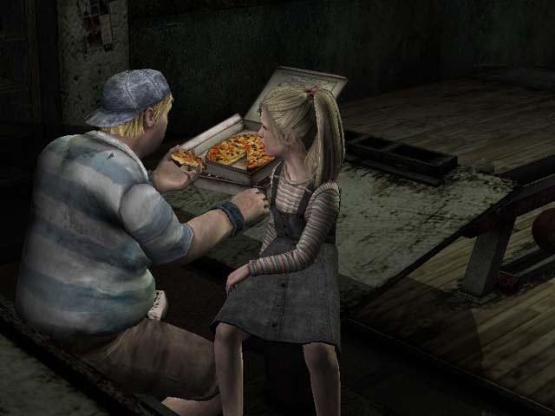
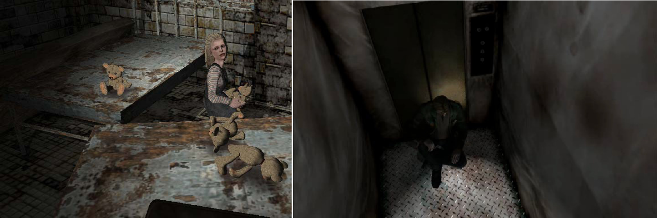
The chase leads them to Brookhaven Hospital, where upon entering Maria falls increasingly tired and decides to stay in one of the rooms, leaving James to find Laura. James finds Laura and learns that she has known Mary for the last year, James argues this point implying that it is impossible, for this, Laura locks him in a room full of monsters under the false information that the room contained a letter from Mary. After the monsters are defeated, the hospital undergoes an “other worldly” transformation and in this other world, Maria is missing. James finds Maria in the hospitals basement and after a small reunion; they are chased by the Pyramid headed monster. Attempting to make a quick escape down a winding corridor, James successfully makes it to the elevator, but Maria is not so lucky, getting trapped behind the half closed elevator doors. The Pyramid headed monster kills Maria for James to see, and James is again alone. Upon exiting the elevator, James notices Laura make a hasty exit from the hospital. Outside the hospital, behind a statue lies a key to the Silent Hill Historical Society, James’ next destination.

The Historical Society opens up to two locations not on the Silent Hill map. First the Toluca Prison and then leading off that is the Labyrinth. The Labyrinth is where the Pyramid headed monster resides and is also miraculously where James finds Maria, alive in cell which she sensually asks James to come and get her. James is unable to rescue her as by the time he finds the route to her cell door; she is dead, killed by the Pyramid headed monster again. It is in the Labyrinth that both Angela and Eddie find validity of their beaconing to Silent Hill.
Documents found in the prison imply that Angela killed her father after many years of physical and sexual abused condoned by her mother. James rescues a distressed Angela from a monstrous incarnation of her father, only to receive more animosity and anger from Angela.
Eddie by this point has been forced to snap by the Labyrinth, disclosing that he killed a football player, a dog, and then shot the dog’s owner. It is apparent that by the time Eddie entered Silent Hill he had in fact gone insane, killing anyone who so much as looked at him funny. This

insanity quickly focuses on James, who is forced to shamefully kill Eddie in self defence. It is killing Eddie that forces James to seriously consider his reason for being in the town.
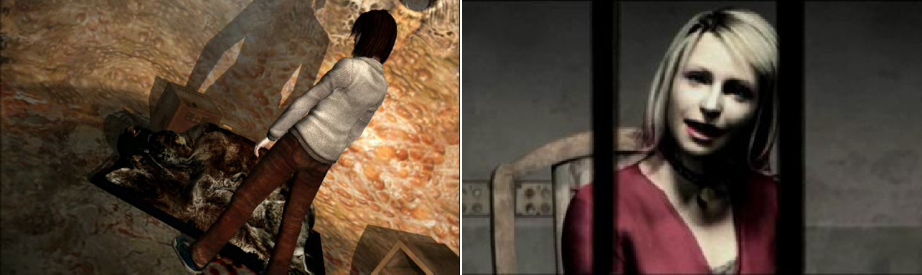
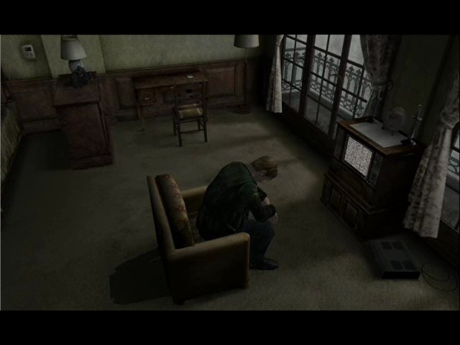
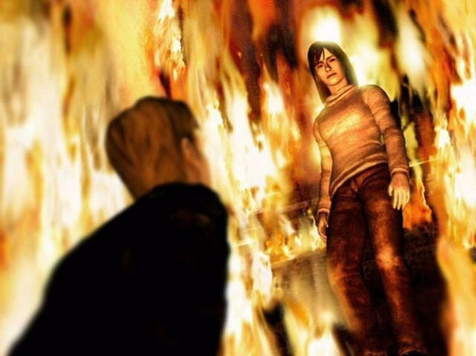
James exits the Labyrinth and acquires a small rowboat to cross the lake to the hotel. On his arrival James notes that the hotel hasn’t changed since his last visit 3 years ago. Inside James finds Laura, who is considerably more co operative now. She gives James a letter that Mary wrote, which states that Mary wanted to adopt Laura, and gave substantial evidence that Laura had in fact know Mary for the past year. The truth is revealed to James after he enters the room which he and Mary shared; containing a videotape he apparently left in the room 3 years ago. The video tape played a home movie of Mary in the room of the hotel, speaking fondly of Silent Hill, then the video dramatically changes, showing static filled images of James smothering his terminally ill wife with a pillow. Laura finds James and expresses her wishes to carry on looking for Mary. James reveals to Laura that he in fact killed Mary, which makes Laura upset and she abruptly leaves. It is at this point that the radio James has been carrying with him picks up a transmission, which sounds like Marys voice asking James to find her. On his exit from the room, the whole of the hotel has taken a drastic chance of decor. The walls are now burnt out and water is leaking everywhere, like there had been a fire. Further inspecting the hotel, James finds Angela standing on a burning staircase. She asks James back for the knife so she can commit suicide, but James refuses to give it to her, Angela believes James is saving it for himself, but James reinforces that he would never take his own life. Angela starts ascending the stairs and James makes a comment stating “it’s hot as hell in here”, Angela replies “you see it too? It’s always like this for me”, signifying that Angela’s life was a constant living hell. She ascends the staircase to an undetermined fate.

James continues to encounter Maria yet again who is screaming out for his help.
Maria is then killed violently in front of James by two of the Pyramid headed monsters. James falls to his knees and begins to realise that the two monsters were created to punish him for his sins, and that he does not need them anymore. The two pyramid heads impale themselves and James is left to continue through a metal style complex with a long winding ascent, and the stories climax.
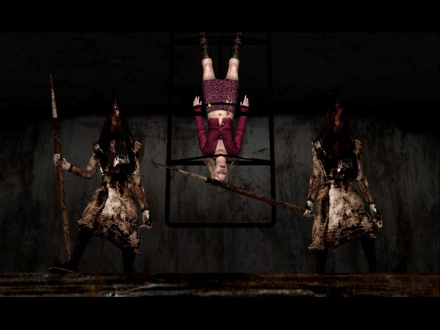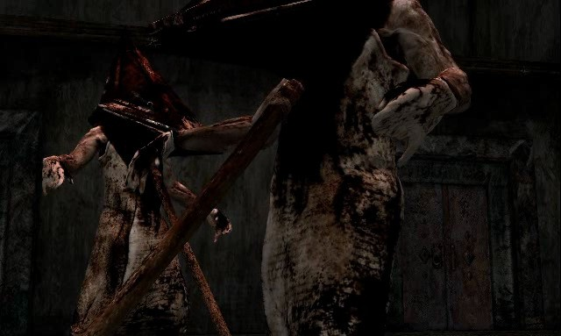

Multiple endings
“Leave” Ending
At the top of the metal steps James finds what he assumes to be Mary, but is in fact Maria in Mary’s clothes. James tells Maria that he doesn’t need her anymore, but Maria intends to take James down with her. Maria transforms into a monster and James kills her. After Maria is dead, the scene changes to James at Mary’s bed. James asks Mary for forgiveness, stating that his reason for killing her was because he wanted his life back and he hated her. Mary forgives him in the sense that she asks him to do one last thing for her, and go on with his life. Mary hands James a letter and she passes away.
Mary’s letter is read aloud and in full as opposed to the section James reads at the beginning of the game. After, James and Laura are seen at the graveyard where James met Angela, and they leave Silent Hill together. It is insinuated that James fulfilled Marys wishes and adopted Laura.

“In Water” Ending

The same set up as the “Leave” ending, but after Maria is dead an altered end scene occurs. Instead of Mary accepting James’ plea for forgiveness, she abruptly tells him that he is paying for what he has done. Mary hands James a letter and passes away. After this scene James is seen carrying Marys body out of the room. The screen turns black the audience hears a car starting, while James expresses that he didn’t know why he was so scared. The audience hears a loud splash and Marys full letter is read.

“Maria” Ending

When James reaches the top of the stair case he finds Mary. He explains he came all this way just to have the possibility to see her again, but Mary is angry. Despite his best efforts to explain his actions to Mary, she verbally attacks James, stating she could never forgive James for what he did. She transforms into a monster and James eliminates her. After Mary is dead, the scene changes to James and Maria by a bridge. James decides to leave Silent Hill with Maria, stating that Mary is not there anymore and he wants to be with Maria.
Marys Letter is read out in full. After it is read out, Maria and James start to ascend a set of stairs back to the start location of the game. Maria gives out a small cough in which James retorts “You’d better do something about that cough”.
“Rebirth” Ending

This ending sees James take on Maria at the top of the steps and after she is defeated, the scene changes to James rowing the same boat he used to get to the hotel. It is implied that Mary is dead in the boat with James, expressing how he cannot go on without her. James finishes with the sentences, “This town, Silent Hill. The Old Gods haven't left this place. And they still grant power to those who venerate them. Power to defy even death.”
James intends to resurrect Mary somehow, how is left up to the players imagination but with James and Laura the only two people left alive, it would suggest a sacrifice.

“Dog” Ending

This ending is the comic relief ending. Through means denoted by game play, James stumbles in on a Dog controlling multiple computers. James falls to his knees and says “It was you all along!”. The dog proceeds to lick James’ Face. This ending is unattainable by fighting the end boss.
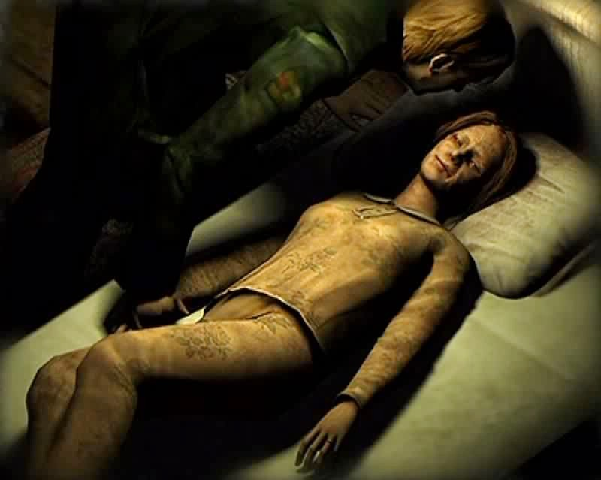

Level Overview
Silent Hill consists of 2 “worlds”, the “normal” world of a derelict town and the demonic repulsive other world. The map layouts for this demonic world to not inherently manipulate the geometry of the surroundings, instead they unlock previously locked doors, leading to whole new section of a building.
Below is a series of maps, each with specific events listed. As well as the puzzles encountered within the level, and their respective solutions.

Silent Hill
The Decor of Silent Hill is that of a derelict nature, although there is a distinguishable essence of community about it. The fog that encases the town almost washes out any colour the town previously had to offer. A lot of the business’ appear to be small independent ventures, not noticeably having a huge shopping outlet. The only main attraction is the Lake Side Amusement Park which sits behind the Hotel, though the peace and tranquillity of the town could be seen as an attraction by many. Abandoned cars and monsters are the main things cluttering the streets of Silent Hill now.
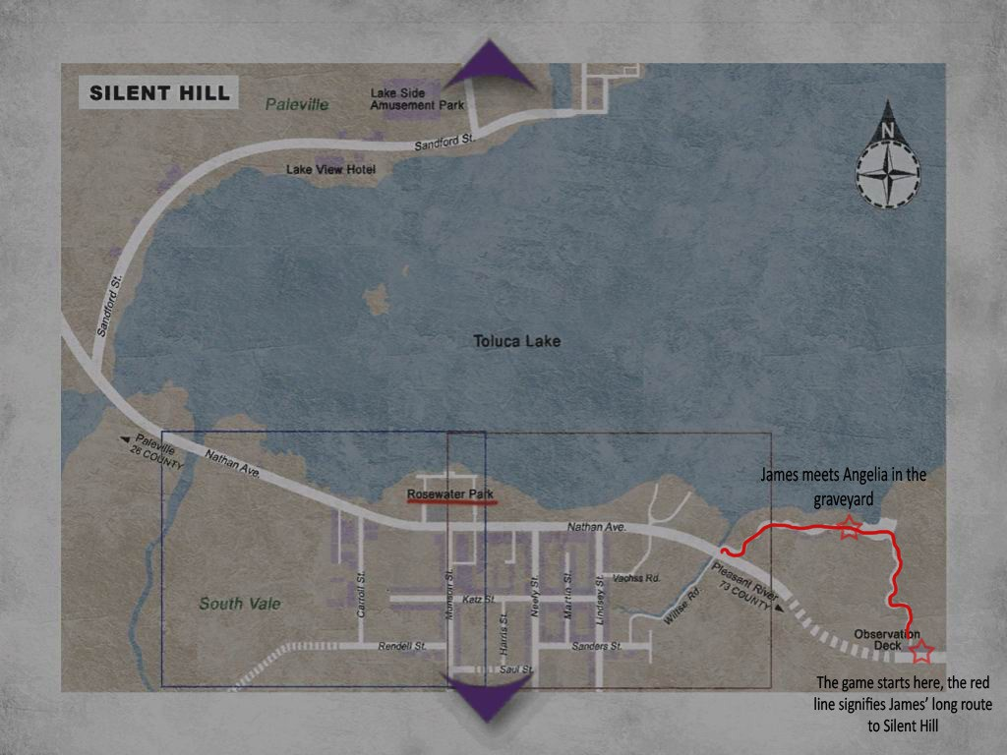

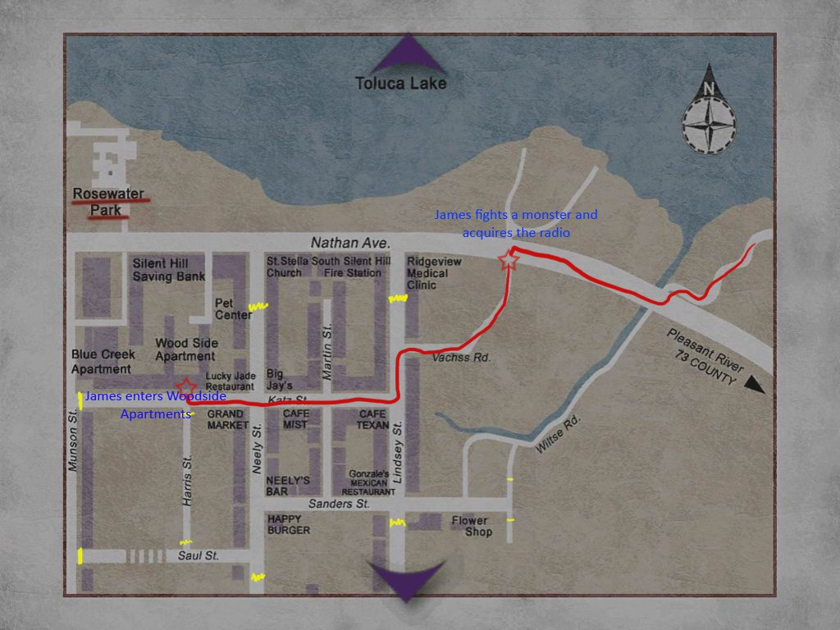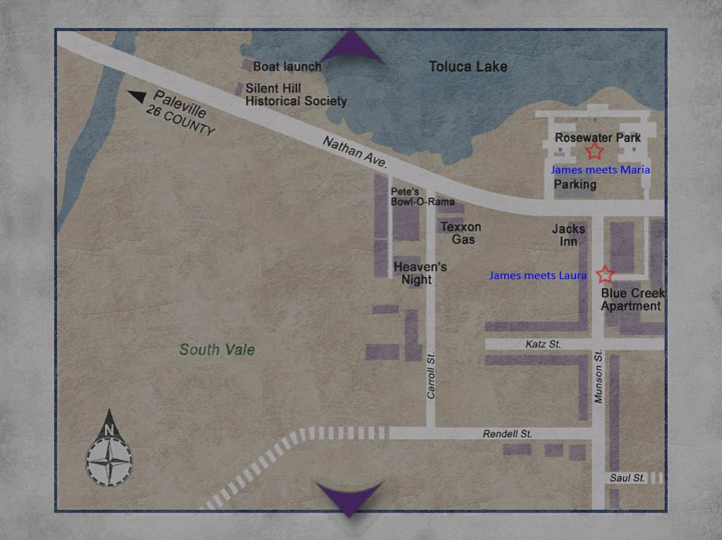

Woodside Apartments
The Apartments are relatively run down with paint peeling off the walls. Not much clutters the halls but each room has been uniquely used. A rusted stairwell spans the 3 floors of the apartment block, each floor containing monsters. James meets Eddie for the first time in this apartment block, as well as encountering the pyramid headed monster.

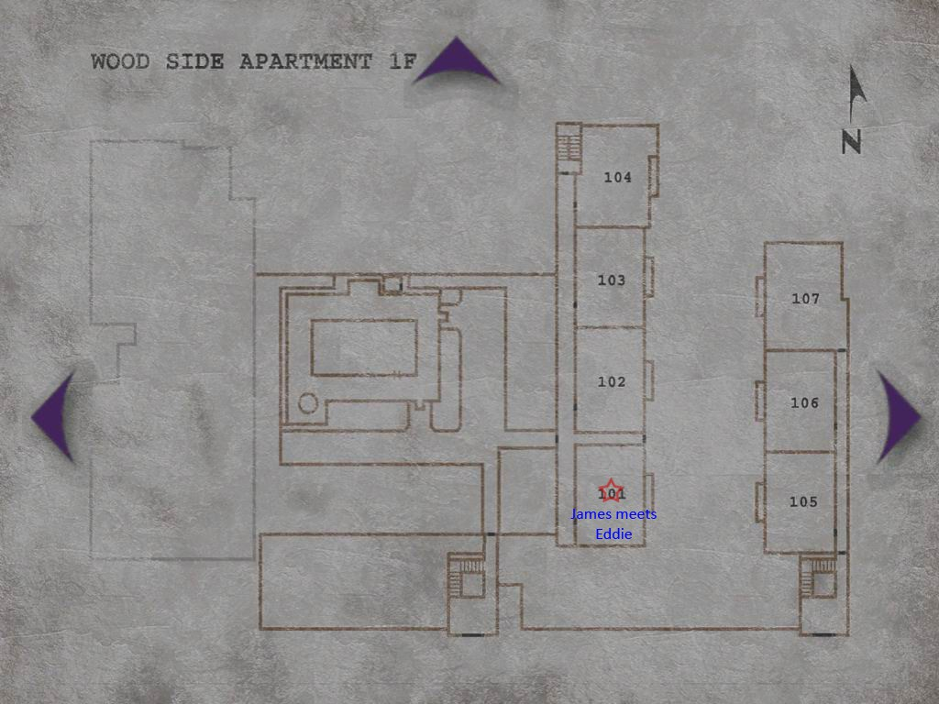

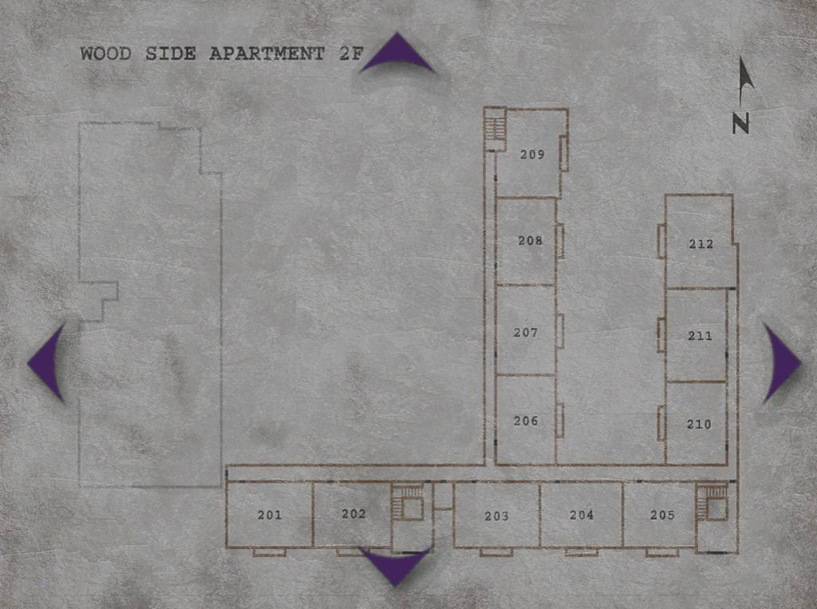

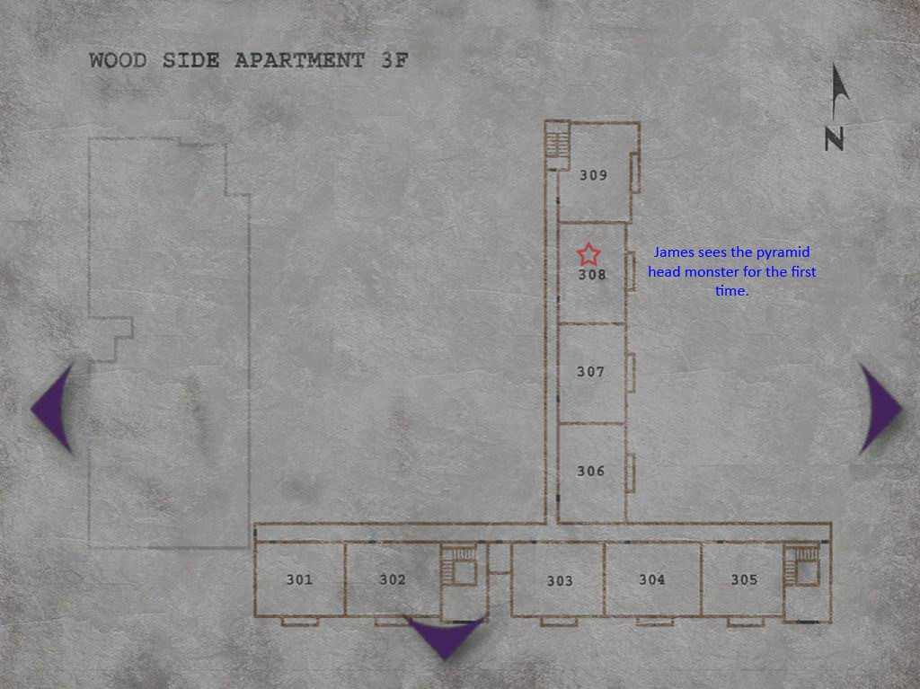

Blue Creek Apartments
The Blue Creek Apartments was built next to the Woodside Apartments. Blue Creek is accessible through Woodside, by using a fire escape that was knocked down to allow room for Blue Creek. The decor is near identical to Woodside Apartments, except for the distinct hint of blue pain in the hallways. Monsters still roam the hallways, and a second appearance from the pyramid headed monster is made. James also runs into Angela here for the second time, and convinces her to give him her knife.

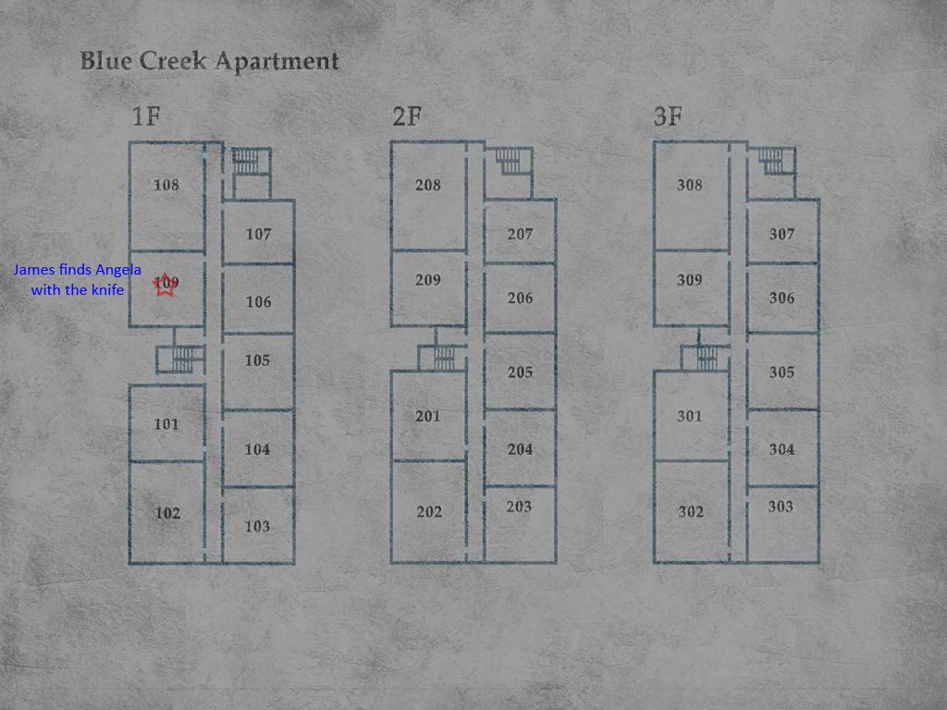

Brookhaven Hospital
Brookhaven Hospital has a distinct decor, containing abandoned medical equipment, operating tables and wheelchairs in the hallways. The walls have also seen better days, showing signs of plaster falling from them, and in some sections, ceilings entirely caved in. Brookhaven is the first place to undergo the other worldly transformation. Doors become blocked by boxes or materials, the walls are covered in tarp and many new disturbing noises can be heard, especially a pig squealing in the basement. This building has an intense feeling of abandonment and a distinct void of life. James suffers another encounter with the pyramid headed monster here, as well as having Laura lock him in the examination room.
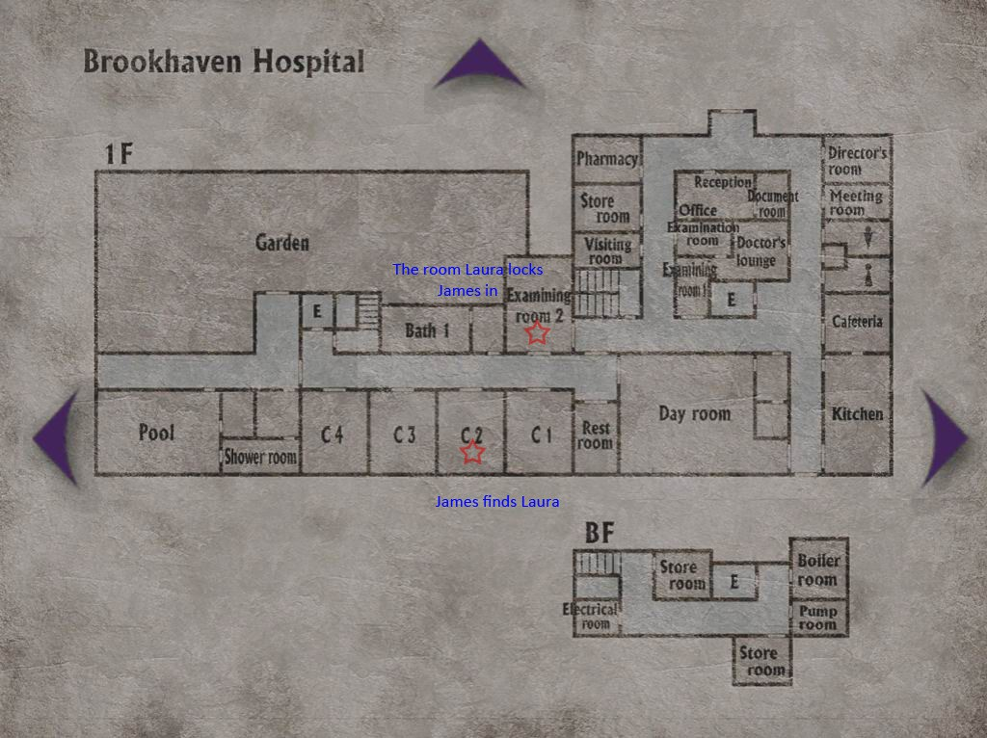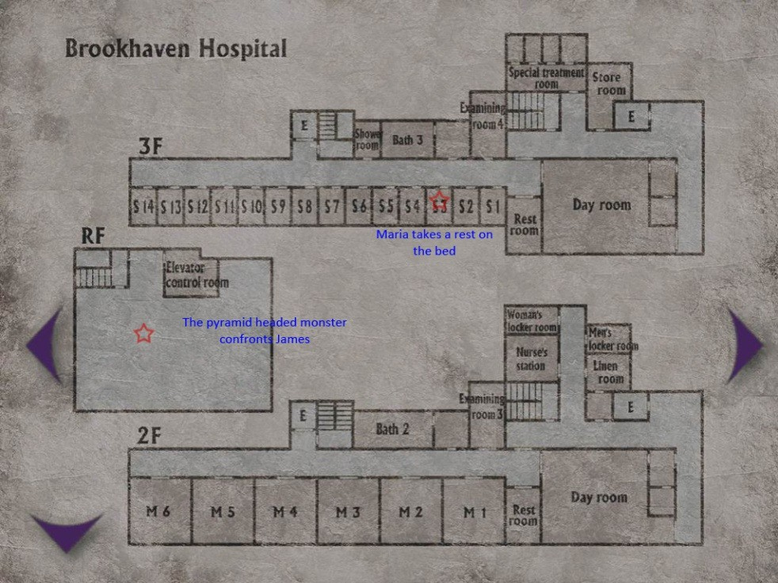

Toluca Prison
The Toluca Prison is not situated on any map of Silent Hill, but in game it will appear to be situated underneath the Silent Hill Historical Society. The prison is separated into three main sections, dictated by the long corridors between them. The far left of the map comprises of visiting rooms and civilian offices. The middle section holds the cells and other such rooms like shower rooms and inmate essentials. The far right is the prison courtyard. When the alternate world is triggered, the courtyard quickly shifts to a field of gallows, it is here that James finds his own gravestone. The decor is drastically caged and run down. The floors are covered with a combination of dirt and blood. Just like the hospital, the prison has the feeling of a severe void of life, except for the monsters roaming the hallways.
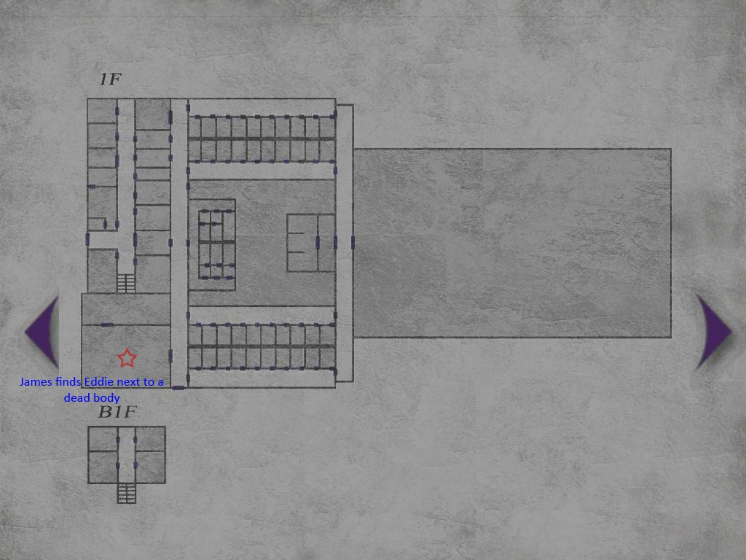

The Labyrinth
The Labyrinth is situated below the prison and has the appearance of a derelict unused building. The walls look in relatively good shape except for a few red stains across a small amount of the walls. This section is where the pyramid headed monster appears to reside, and where James is able to enter what seems to be his workshop and steal his weapon. The pyramid headed monster is also seen roaming the halls of the lower labyrinth. The halls look relatively similar with numerous ladders and doors, making it easy to get lost in.
Symbolically, this location is the place when the key characters overcome their own “mental maze”.
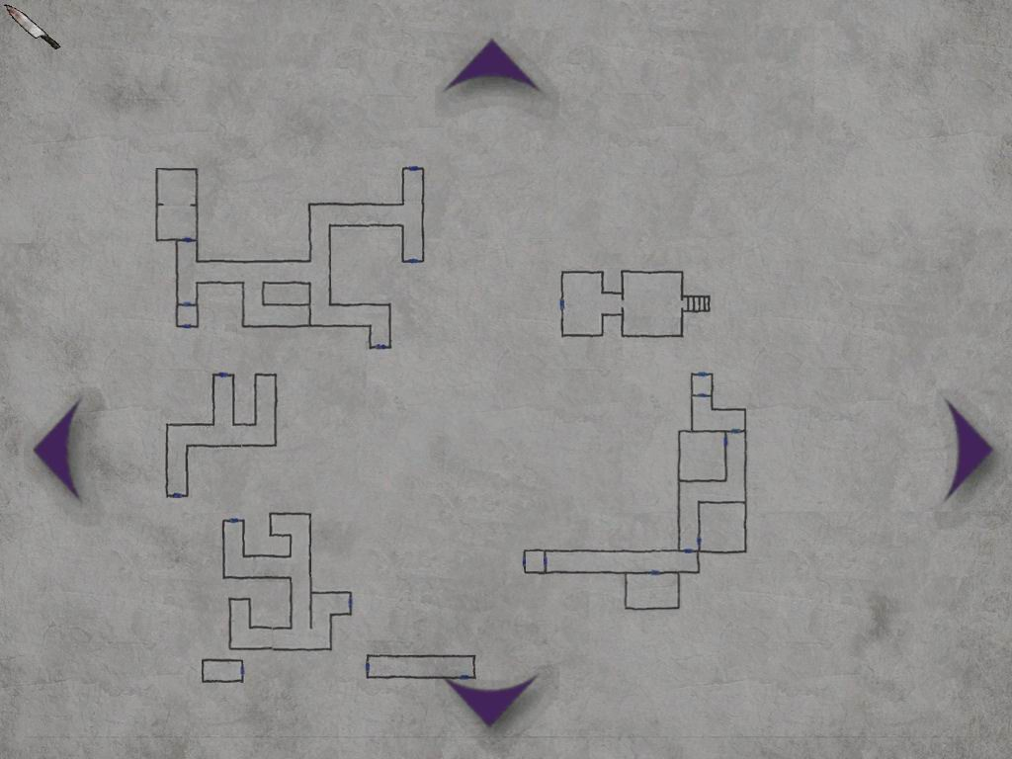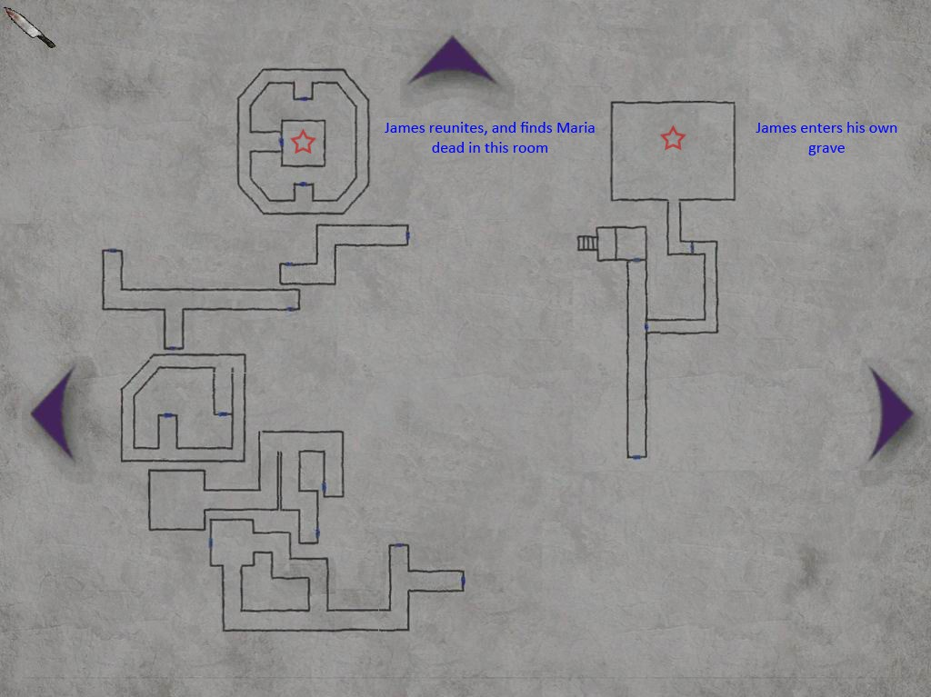

Lakeview Hotel
When James arrives at Lakeview Hotel it appears to be just how he remembers it. The
hotel seems to be in good shape, with floral wallpaper and a grand piano, it looks like a nice place to stay. The whole hotel is caked in a layer of dust though, further encompassing that isolation and desertion. Once James sees the tape indicated in the story, the whole hotel changes into the charred remains of a hotel, like it had been burnt down. The hotel comprises of three floors and a basement, monsters roam before and after the dramatic change.
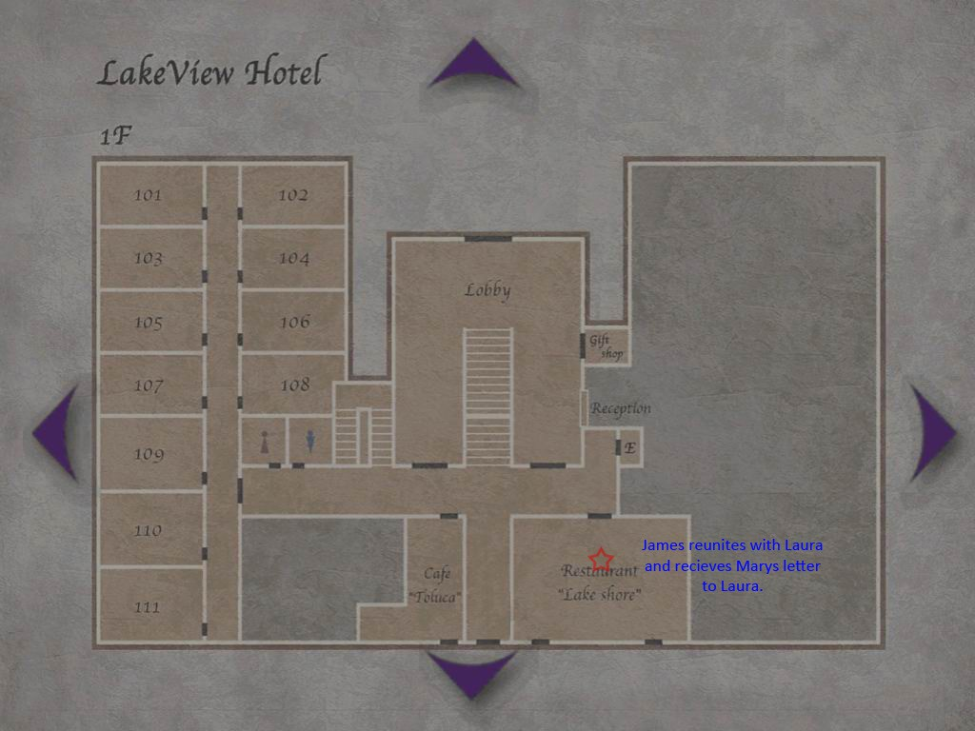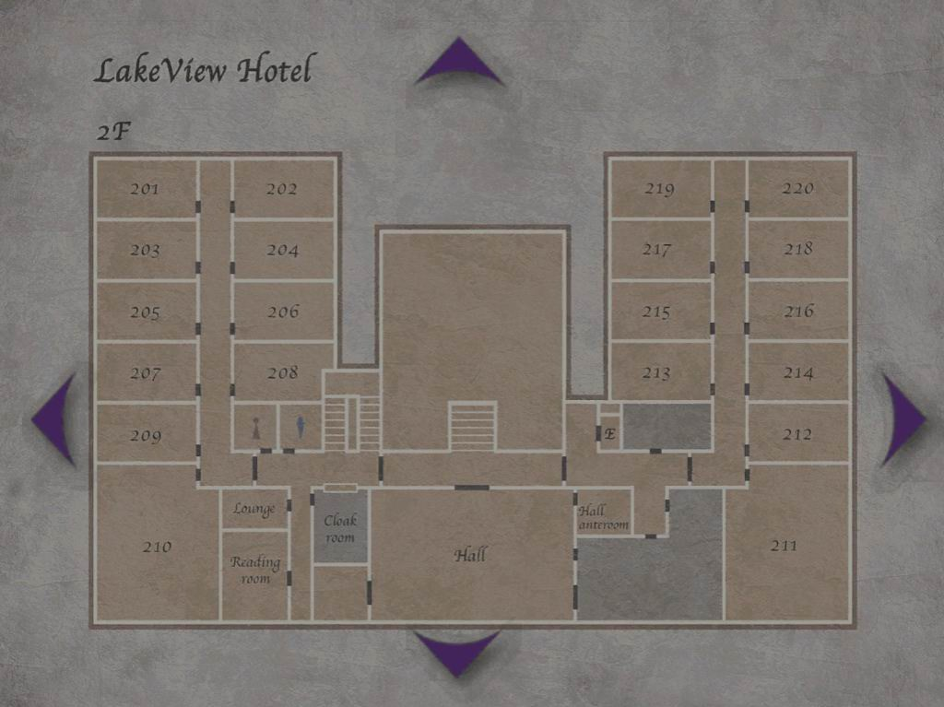

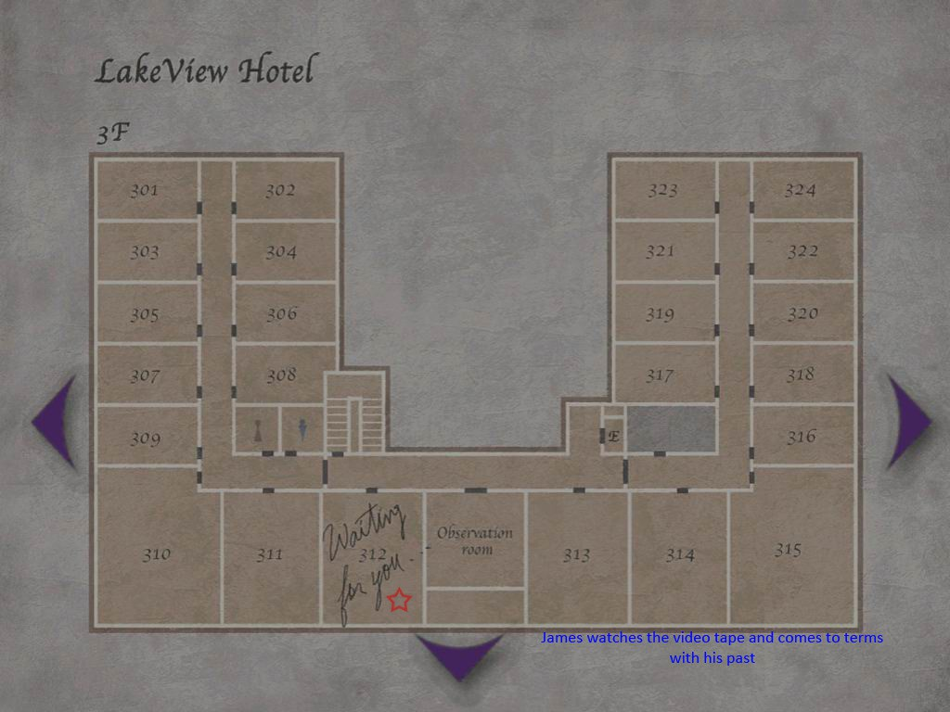
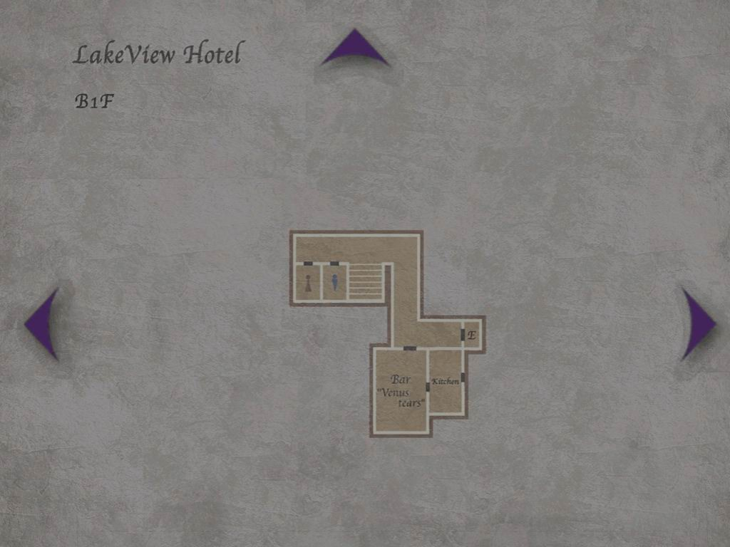

Puzzles

Clock Puzzle (Woodside Apartments - room 204)
On a wall opposite a clock there is a carving in the wall with three names, Henry, Mildred and Scott. There are lines next to each name, all pointing in different directions. There is a document close by which has this information.

Easy – “Three different sizes, time on the run. Three young men circlin' round the sun.
Henry is short and very, very slow, Scott can't stop, he's always on the go.”
Normal and above – “Three needles stand of three different heights. The fat, the tall and the thin. From slow to fast they move to the right. Scott rests not on three, but fifteen”

The solution is the same for both difficulties. The names depict time, Henry = Hour, Mildred = Minutes and Scott = Seconds. The player has to move the needles on the clock to match the line directions associated to the name.

Safe Puzzle (Blue creek Apartments - Room 203)
The combination to the safe is hidden in a toilet.

Easy to Normal – The numbers are randomly generated. It is opened in a padlock style by spinning the dial in different directions. The directions to turn are depicted on the document found in the toilet.
Hard – This is the same as easy but the numbers are partially replaced by roman numerals.
Extra – Letters A to K replace all of the double digit numbers (10 = BA, 24 = CE).

Cabinet Puzzle (Blue Creek Apartments - Room 105)
Three coins are required to complete this puzzle, an old man coin, a prisoner coin and a snake coin. The coins will be placed in the surrounding areas. There is a cabinet with 5 holes that will fit the coins. The inscription on the cabinet reads as follows.

Easy – “To the right is the lady / To the left is the old one / In the center draws the other / Now just two spaces remain / But fear not for now / The puzzle is done / The puzzle is done.”
Easy Solution - Old Man, Space, Snake, Space, Prisoner.

Normal – “Three bright coins in five holes be At one end sits / the Seducer of she / The wind from behind / the woman doth play / The Formless One / Null, lies furthest from they / The Old One beside / the Serpent sits not / Tis to the Prisoner's left / that he doth rot “
Normal solution – Space, Old Man, Prisoner, Space, Snake.
Hard – “First lies the seat of / He who is Peerless Silent and empty / heartless and fearless / Beside him sits one who knows / The place of the servant is / next to throne.

Dozens of feet / yet not a single toe / The One that is Hidden / beside him doth go / Seducer of dreams / creature of Hades Lying further from / Man and closer to Lady

Man and Woman seeing all / Heedless to the Raven's call / Silent and Hidden the two may be / They be not there for you to see / Return them to whence /they would be / And blessing shall
/descend on thee

I speak thus with / the North Star behind me / The birth of the sun is / the start of the story”
Hard solution – Space, Old Man, Space, Snake, Prisoner
Extra – “Like coins in the hazy / aether tossed / Our souls must by / their sinful weight / Descend to earth / with lightness lost

To "right" the sins / that they hath laid / When thrice in falling they intone / The Happiness shall be thy own / The first note be not by / the Horned One rung / Though it be there that / all sins be sprung

The Bringer of Life and / the Bringer of Shame / The sins of the latter be / even more tame Though coming / in the Aged One's wake / The Formless One's soul / in fear doth quake
The Needless One, silent, / with hungers all sated / Is least then in sin / with his lusts all abated

For the gravest of sinners / His place be appointed / And if he be lucky / May his soul be anointed”
Extra solution – Old Man, Space, Snake, Space, Prisoner

Trick or Treat Puzzle (Brookhaven Hospital - Store Room)
Randomly entering this room triggers a voice on the intercom. The player answers via an onscreen prompt.

All difficulties - Merry-Go-Round, haunted house, roller coaster, ferris wheel and tea cups. Silent Hill is home to a thrilling amusement park that both children and adults love. The question is: What is the name of this amusement park?
- Fantasy Land; 2) Silent Hill Amusement Park or 3) Lakeside Amusement Park
Silent Hill witnessed a gruesome murder a few years back. A brother and sister were playing in the road when they were attacked and chopped into pieces with an axe. Torn flesh, smashed bones, splattered blood, and finally... What a terrible tragedy. What gruesome end to such innocent lives. What was the name of the murderer who committed this vile act?
- Walter Sullivan; 2) Scott Fairbanks or 3) Eric Gein
South of the lake is a deserted old neighborhood called South Vale. From there to Paleville, the central resort area northwest of the lake, there's only one road you can take. Just one road, no more. The third and final question is: What is the name of that road?
  - Bachman Road; 2) Rendell Street or 3) Nathan Avenue
Answers - Question 1: Lakeside Amusement Park Question 2: Walter Sullivan
Question 3: Nathan Avenue

Face Cube Puzzle (Labyrinth Beneath Prison)
The player must rotate a cubed head which simultaneously rotates the position of the room. The player must rotate the room until there is a exit other than the entrance they used.

Hanged Man Puzzle (Execution Rooms in Labyrinth)
The player is confronted with a sign by 8 empty nooses.
“Only the sinless one / can help you here / Mistakenly pull on / a criminal's rope and / your reward will be returned / to you in a shape most / wondrously strange”
In another room the player is confronted with bodies in body bags, hanging from nooses. The puzzle is completed by pulling the empty nose of the criminal who is innocent. (Murderer, Arsonist, Bodily Injurer, Counterfeiter, Thief, Embezzler, Kidnapper, and Swindler)

Easy –

He committed an evil crime / He turned a happy home /into a pile of ash / For that, he should die.
They also committed crimes / They tried to fraud /and trick others. / So their reward too is natural.
Even he cannot be forgiven / My friend without his left hand / And so his death bothers me not. And what of him? / He also is not sinless. / There is only one here / who is innocent.
The missing child was / nowhere to be found, / And so there was / no proof of his guilt. / His death was a tragedy.
That is all I wish to say. / It was neither justice / nor retribution.
Easy Solution – The Kidnapper
Normal –
Dead men, dead men / swinging in a tree / How many dead men / do you see? / Tongue turned blue and / face gone grey / Watch them as they / twist and sway
The first one killed / the butcher man / Then cooked him in / the frying pan / Served him to his hungry guests / And gave them seconds on request
The next one with his smile / and sweets / Stole poor children off the streets / To men who dressed unsavory / He sold them into slavery
Breaking into home at night / The thief he had a nasty fright / Filled his foolish head with ale / Woke in the morn in the county jail

The artist with his daunting skill / Tried his hand at painting bills / But caught in rain he was undone / When the ink he'd use did / start to run
With promises of great return / Taking gold he did not earn / Bundled it up out of sight / Quietly slipped off into night
Three houses into ashes burned / The sheriff with no place to turn / Did spy a stranger to his town / Locked him up and beat him down
Dead men, dead men / swinging in a tree / How many dead men / do you see? / Six feet long and /six men wide / Round their necks / the noose be tied

Normal Solution – Arsonist
Hard –
"I do not wish to die / But tomorrow I will climb / the thirteen steps. Please someone - answer me / Why must I die come the morning?
The man imprisoned beside me / believed me. "Because they're / all insane, that's why," he said / Of course I know his opinion / will change nothing. "Now you / know why I struck out at them," / he muttered.
The man who was executed / yesterday, the one who had / said his job was to sell dreams / said that was not true.
But the man who is to be executed / the day after tomorrow for stealing / children shouted back that it was / true
The man who was hung today / did not answer. "They'll kill me / either way," he said. He was / caught embezzling public money / so he hasn't any hope for mercy
The man who is always quietly / smiling to himself said "I am / happy for I will soon be with her."
I do not wish to die / I long only to return home. / But I know it is not to be. / Though I have done nothing, this / crime has been thrust upon me.

Someone save me. This is not / judgment. They are bloodthirsty / and I am their sacrificial lamb!"
Hard Solution - Counterfeiter
Extra –
“We may visit death upon the head / of the sinner but to what avail?
In the name of retribution / we took part in a bitter / comedy this day You, hanging as you do / by your neck / Unforgiven and cursed by all.
Five of them committed crimes, / six went out for a drink and / were captured there. Only one of them was innocent, / but they knew not that.

The bloodstains remaining / are proof of their guilt. / Trodden upon and thus created, / they are paths to / Hell or the Void.
The white bandages stained / with crimson, / The remains upon the scorched / black earth, / The whispered cries of the maiden. / They are but meaningless / contract.
They are also signs of guilt.
But one of them was / done without reason. / It was done out of fear / and a ripe imagination. Sinning alone at the / end of a rope / it is nothing less than / a disgrace to us all.”
Extra solution – Thief

Music Box Puzzle (Lakeview Hotel - Lobby)
This puzzle requires the player to put a selection of collected music boxes in the correct slots, based on a riddle. The three music boxes are Cinderella, Snow White and The Little Mermaid.
Easy – “When the Lost One is returned / the sour note shall turn sweet”
Easy solution – The music boxes can be placed in any order. Normal – At this level, there are inscriptions at each placeholder. Normal solution -
“Seat of the Princess / who fled at midnight” = Cinderella “Seat of the Princess / who awoke from death” = Snow White
“Seat of the Princess / who spoke no words” = The Little Mermaid
Hard and above – The same as normal difficulty, each has an inscription.
Hard and above solution –
“Twas shameful greed did stain / her shoe with blood” = Cinderella “Beauty - Both a blessing / and a curse thou be” = Snow White
“Even so, I still want to believe / that she was happy” = The Little Mermaid

Market Analysis

Target Market
Silent Hill will be developed for the Playstation 2. This platform was chosen as it has a huge install base, which will enable to game to receive a wide reception of audiences. The Playstation platform has proven to be the stable ground for the mature style of game. Silent Hill released on the Playstation as well as the Resident Evil series, which did extremely well.
Continuing previous success, we believe the same consumers of these titles will have converted to the upgraded Playstation 2 hardware, thus the install base denotes our market within that platform. Although sales show the first Silent Hill game did not create as much hype or profit as the Resident Evil series, numerous publishing bodies congratulated the game as being extremely innovative. We intend to further attract the niche audience our first game created and expand beyond that, enticing new players to enjoy the psychological horror. These new players will be placed in the 13 to 25 age range, we chose this as younger players will revel in the combat and gore aspect, while older players will get more enjoyment from the story and the puzzles. Typically the game will aim at a male audience, though the standard of the art direction could considerably influence a female audience.

Top Performers
Silent Hill 2 will be the first big release for the genre on a new operating platform. We can see other titles prom the previous generation which proves the genre is strong. Such titles like Clock Tower reinvented the genre by changing the pace of combat, making is truly about surviving the horror as opposed to shooting everything. Clock Tower went on to split audiences, until it too, created their niche audience. The Resident Evil series, though extremely differently paced to Silent Hill, delivered the classic survival horror experience. Multiple encounters, sudden exhilarating rushes and fantastic art design. It is this pattern which will allow Silent Hill 2 to be a success for not only the platform but the genre. Silent Hill 2 will bring its distinctive style to the table of the next generation, and hopefully broaden the genre for years to come.

Feature Comparison
The main comparison for Silent Hill 2 from previous games will be the obvious graphical leap. The story will harness the power of the platform to deliver stunning visuals and unprecedented emotional involvement. The sound quality will be a major improvement and so will the resolution our game will be playable in. Models and textures will be substantially clearer, with a better capability to encapsulate more on screen at once. The vibration function of the Playstation 2 controller will also add numerous enhancements to the game play experience. Silent Hill 2 will continue its predecessor’s staple on the market, reinventing psychological horror through a level of storytelling maturity not seen in the genre.
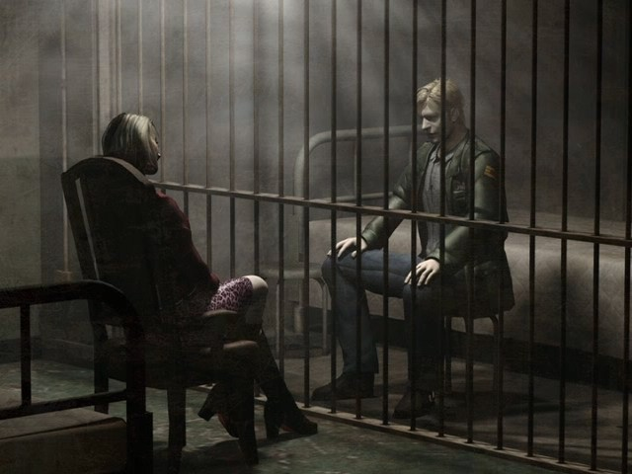

Bibliography
- Silent Hill 2 + Bonus Disk (PS2 + PC) Publisher: Konami / Fun TV
- Silent Hill 2 Official Strategy Guide Publisher: Piggyback / Konami
- Silent Hill 2 Restless Dreams Official Strategy Guide Publisher: Brady Games / Konami
- Silent Hill Lost Memories (DVD) Publisher: Konami
- Silent Hill Media
Url: http://shm.silenthillfever.com/
- Silent Hill Heaven
Url: http://www.silenthillheaven.com/
- Silent Hill Wiki
Url: http://silenthill.wikia.com/wiki/Silent_Hill_Wiki
- Translated Memories
Url: http://www.translatedmemories.com/
- Silent Hill 2 Full Game Script
Url: http://uk.faqs.ign.com/articles/374/374938p1.html
- Andrew Rollings and Earnest Adams on Game Design
- Tim Ryan's "The Anatomy of a Design Document"
- VLC Player (Cut scene pictures)

